National Awards for Disability Leadership

2022 Finalists

Zac Chu – Rights Activism
Zac convened Diet to Save Earth (DTSE) to contribute towards the attainment of UNSDGs 2, 3, 12 and 13. He led the campaign of e-petitioning Australia to sign the Intergovernmental Declaration on Children, Youth and Climate Action, and launched the “Be My Proxy” initiative in the last federal election to ‘enfranchise’ underage Australians. His achievements elevate the status of PWD and inspire youths, in Australia.

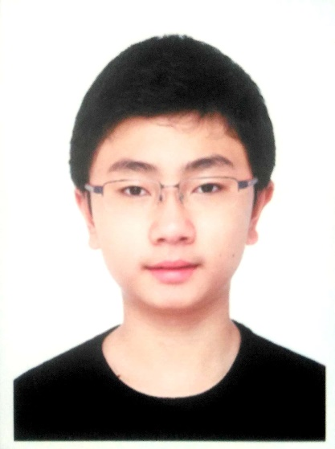

Ace Bonato – Lesley Hall Award for Lifetime Achievement
Ace is a great leader in facilitating social changes through the peer led Social Change Action Group at Diversity and Disability Alliance where disability rights, breaking the barriers, system advocacy, social inclusion, social model for people with disability, circle of support, especially in CALD communities are upheld and tirelessly pursued to ensure a better life quality for people with disability.

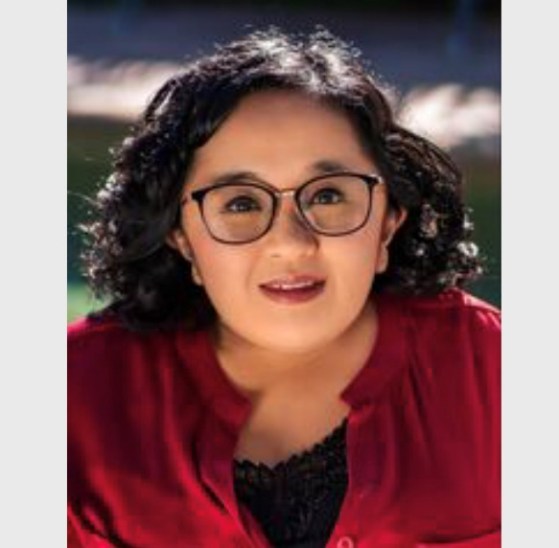

Diversity and Disability Alliance – Inclusion (working intersectionally)
DDAlliance is a user led organisation, run by and for people with disability from diverse backgrounds. An independent collective voice committed to full inclusion, leading the way by delivering innovative peer led programs in order to create social change at individual, community and societal levels. Peer support is the foundation of DDAlliance - maximising knowledge, skills and expertise of people with disability from CALD backgrounds. Innovative programs thrive: Peers come together for mentoring, facilitator training, ‘Peer Cafes’ in numerous languages, learning hubs, peer led research, Circles of Support, and Communities of Practice. Leading by example to create an inclusive just society.

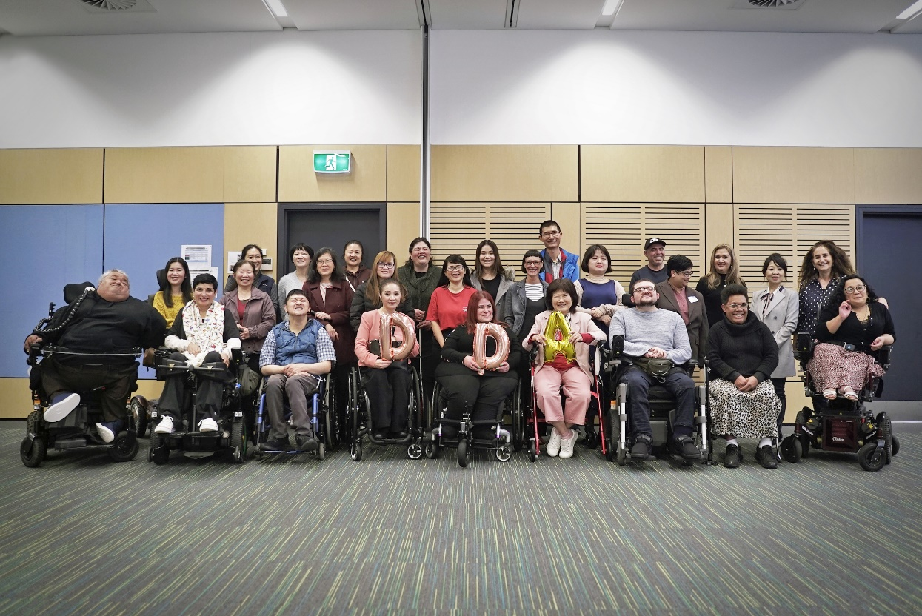

The University of Sydney's Disability At Work Network (DAWN) Steering Committee – Innovation
The Disability At Work Network (DAWN) is a staff network at the University of Sydney. The network is led by a voluntary Steering Committee comprised of staff with lived experience of Disability. Their mission is to build community and lead change on Disability issues at the University. In 2022 they pioneered multiple programs and initiatives to build awareness and to improve ease of access at the university.

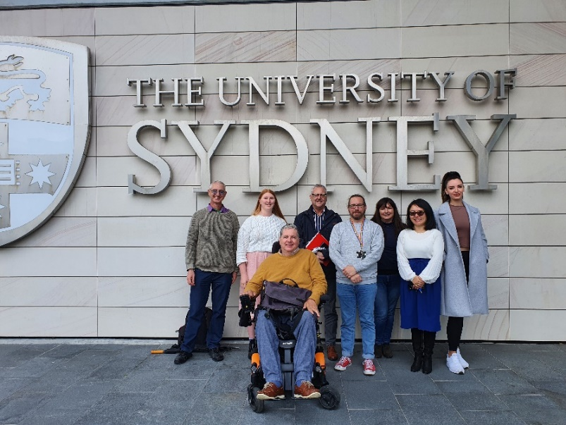
Stephanie 'Stevie' Russell-Farnham – Social Impact
Through her social enterprise, EmpowerME Enterprises, and her work with Women with Disabilities Australia (WWDA), Stevie has become a powerful advocate for women and girls living with disability, especially the often overlooked 'invisible' disabilities. Her willingness to share, through her speaking engagements and through social and mainstream media, her personal struggles of living her best life with ‘invisible’ disabilities, is a powerful tool for raising awareness of the disability community. Stevie's communications are about capacity, not incapacity, challenging many of the myths in our society about disability.

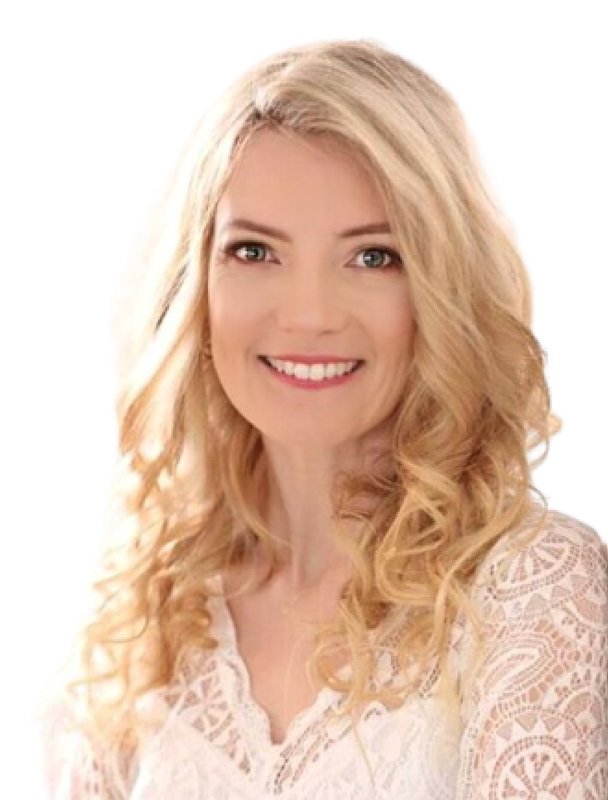

Rebecca 'Bec' Hogan – Change Making
Bec Hogan works for the ABC in the Emergency Team who advise and help staff during disasters, she specialises in digital emergency broadcasting on social media and online platforms. Bec is also the deputy chair of the ABC disability employee group ABC Inclusive and leads the group in access matters. Bec has worked hard to ensure that people with disability can access ABC emergency information, including educating staff on access tools, creating specific content for people with disability to prepare for disaster, help design ABC website, ensured access in workflows. organising events. Bec led a massive audit of content which resulted in technology roll outs, opportunities for people with disability, and positive culture shifts.

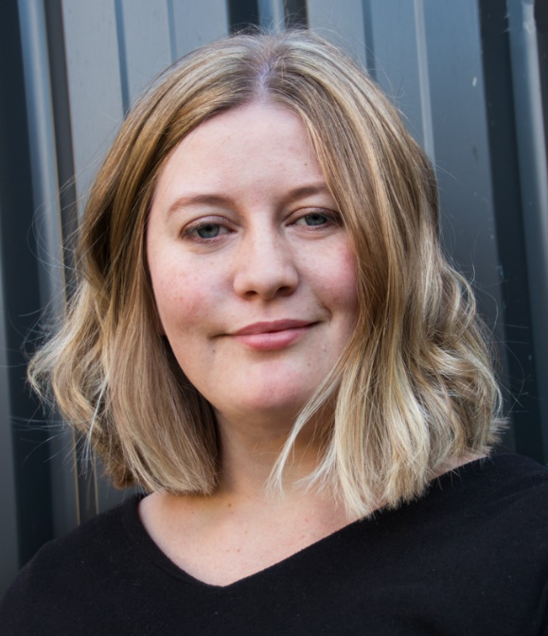
Duncan Steward – Arts – joint Recipient
Duncan Steward is the founder and owner of Platinum Cre8ive (an organisation specialising in representation of artists with disabilities in the creative arts sector in Australia and Internationally). Duncan is also the co-creator and organiser of the online International concert WhiteStick Fest.

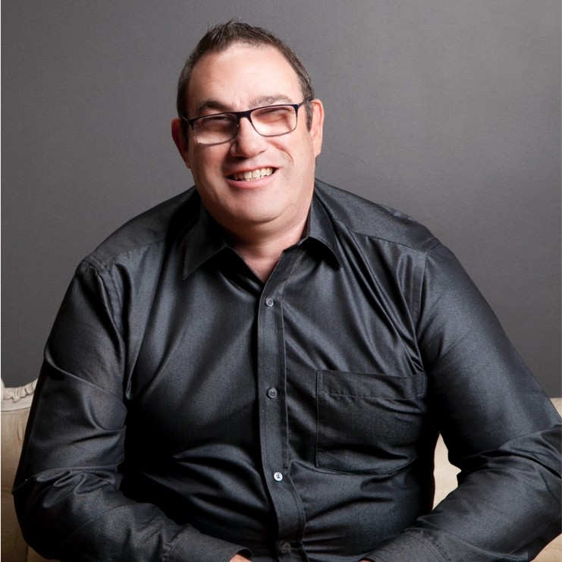

Julia Rose Bak – Arts – joint Recipient
Julia has been writing about their experience growing up as a disabled person since 2017 when their first article was published in Overland. Since then, Julia has written articles for Bitch, Archer (online and the Disability print edition), Honi Soit, Refinery29, and more, all of which discuss disability, disability justice, access, ableism, and collective liberation for disabled people.

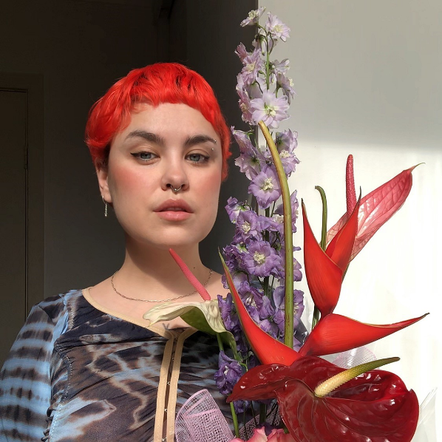

Summary

Lesley Hall Award for Lifetime Achievement
- Ace Bonato

Rights Activism
- Zac Chu

Inclusion
- Diversity and Disability Alliance

Innovation
- The University of Sydney's Disability At Work Network (DAWN) Steering Committee

Social Impact
- Stephanie Russell Farnham

Change Making
- Rebecca Hogan

Arts
- Duncan Steward
- Julia Rose Bak

#DisabilityAwards2022

