National Awards for Disability Leadership

2021 Finalists

Finalist details

Cassandra Grey – Rights Activism
Over her lifetime, in particular this year, Cassandra has been an outstanding young leader and advocate across the disability communities she interacts with. Cassandra uses her lived experience of disability, knowledge of disability issues and background in law for systemic advocacy and impact across multiple areas of society including education, employment, university, rights, sports and law.

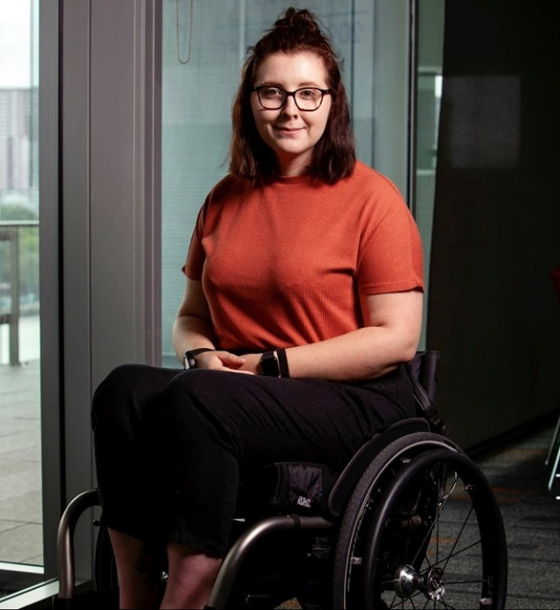

Chloe Polglaze – Rights Activism
By sharing her lived experience, she directly contributed to a significant policy change that will positively impact children with disability around Australia. Following her contributions at the Children and Young people with Disability Australia (CYDA) and Families Australia policy forum, Community Services Ministers’ met and agreed to add a fourth priority group to the National Framework for Protecting Australia’s Children successor plan.

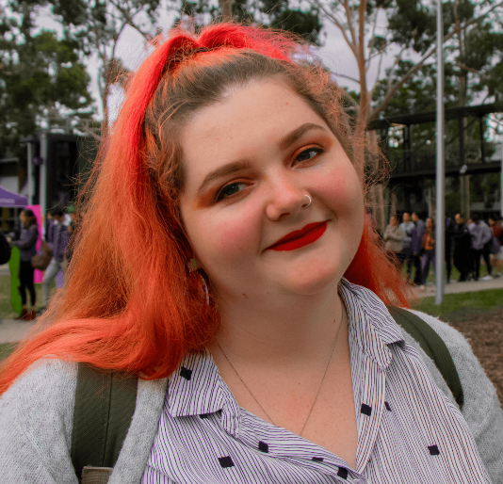

Wenn Lawson – Lesley Hall Award for Lifetime Achievement
Wenn’s impact on Australia’s Autistic community is unparalleled. He works with researchers around the world on vital topics like aging & quality of life, has written 20+ books & co-developed monotropism, a landmark person-centred theory to conceptualise autism. With generosity & wisdom he provides advice, mentors new leaders, supports families & helps ensure Autistic kids’ rights are met at school. Dr. Wenn Lawson was one of Australia’s first Autistic advocates & has educated and helped countless Autistic people, families and community members to see autism differently. Wenn is an experienced researcher, public speaker & author. He's a proud family man & member of the LGBTQIA+ community.

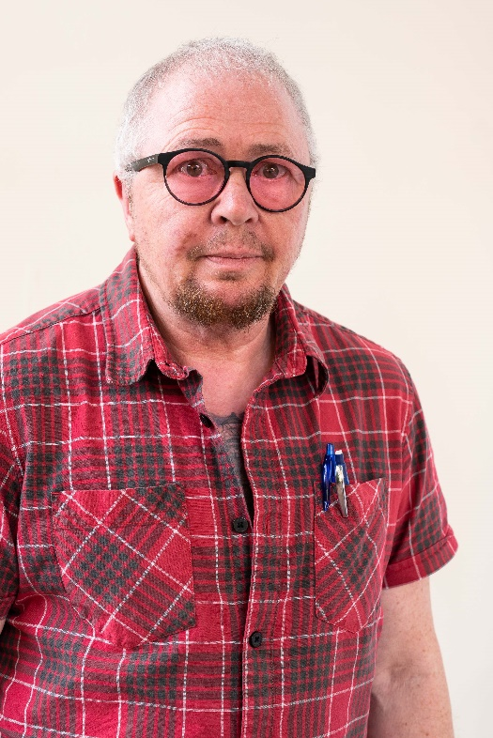

Irene Gallagher – Lesley Hall Award for Lifetime Achievement
Irene has succeeded in achieving Legislative change, Policy changes and changes in the stigma of those with a Mental Illness. Her contribution as a leader of industry is recognised, however her work outside of organisational duties in a volunteering capacity has been long and successful. Irene has mentored many advocates and inspired many more.

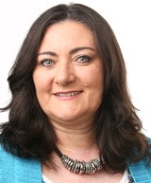

Katherine Gill – Lesley Hall Award for Lifetime Achievement
After decades of research and advocacy, Katherine founded FND Australia Support Services Inc in 2017, to close systemic care gaps, without discrimination, providing equitable and inclusive access to professional support and services for all Australians with FND. This has been life changing for hundreds of people with FND, with significant outcomes after being denied access to care for many years.

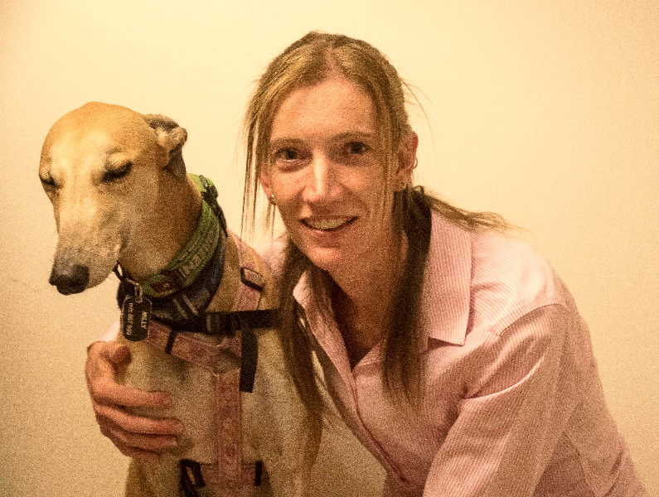

Helen Flinter-Leach (posthumous) - Lesley Hall Award for Lifetime Achievement
Helen Moira Flinter-Leach was a community arts organiser, theatre producer, arts administrator, playwright, actor, and a flamboyant and courageous force of nature! Her pioneering spirit and industrious creativity drew people into her collaborative plans to change the landscape of the arts forever. Helen founded No Strings on the belief that quality work in the arts can positively affect people’s lives, and that legacy continues, with No Strings’ commitment to collaborative co-design of all content reflecting the lived experience of our performers living with disability, resulting in multi-award-winning productions that have toured nationally and internationally to broad acclaim.

Ruby Susan Mountford – Inclusion (working intersectionally)
Ruby Mountford’s contribution to LGBTIQA+ disability communities and work in community development and inclusion has involved co-authored research reports, co-designed resources for self-advocacy and employment inclusion, and developing an Accessibility Inclusion Action Plan for Thorne Harbour Health to reduce barriers and support community participation for LGBTIQA+ people with disabilities.

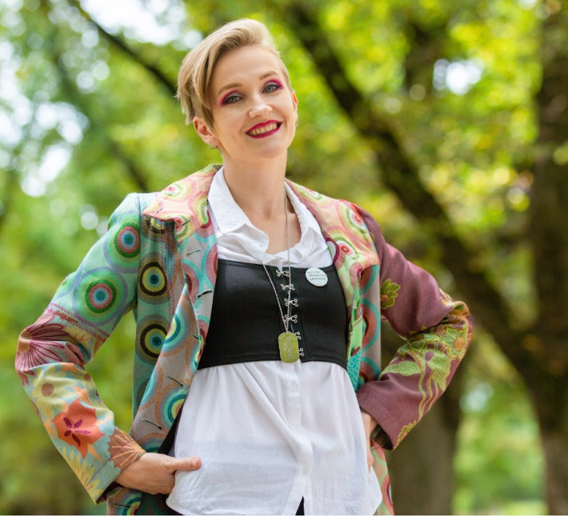

George Ayoub – Inclusion (working intersectionally)
George is a pioneer at the forefront of activism in Australia for 4 decades. By example, consulting, educating, mentoring, designing and implementing programs run by people living with disability from CALD backgrounds. Including establishing the Push and Powers Sports Assn., and Physical Disability Councils across Australia. A leader in the development of peer networks, now thriving online.

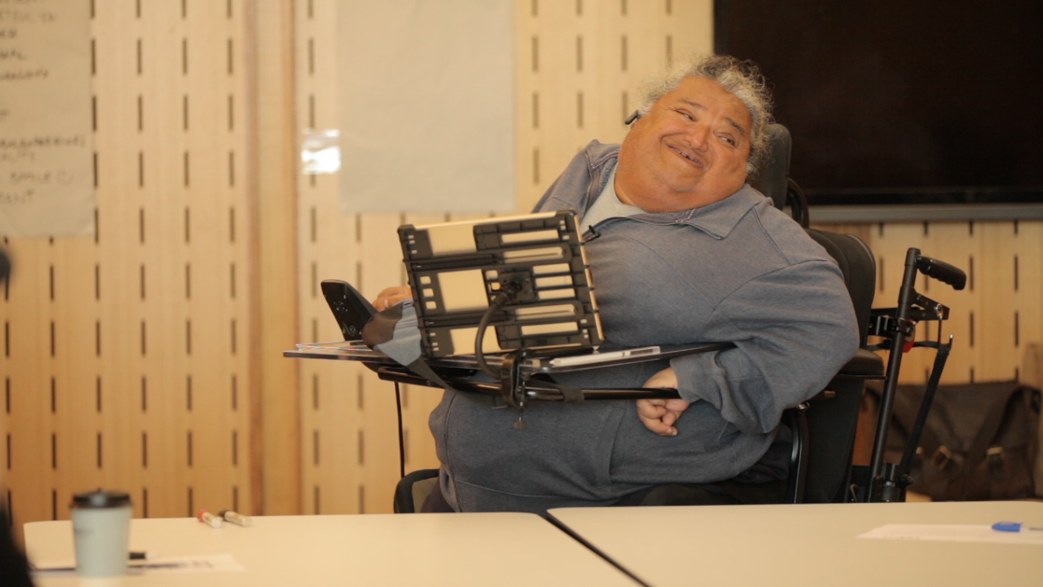

Esha Oberoi – Inclusion (working intersectionally)
Esha Oberoi, CEO & Founder of Afea, a large disability care provider. She arrived in Australia at 7 years of age and experienced bullying and isolation, leading to a host of mental health challenges. 14 years ago, in her 20s she foundered Afea with the mission to prevent isolation and dependency.

Shane Hryhorec – Innovation
Shane connects communities, councils, surf life savers clubs and people with disability around Australia to make over 50 Australian beaches more accessible. Shane regularly delivers beach access training and workshops, lived experience advisory, hosting community accessible beach days, organising equipment test and trials, and has created a free online accessible beach and waterway directory.

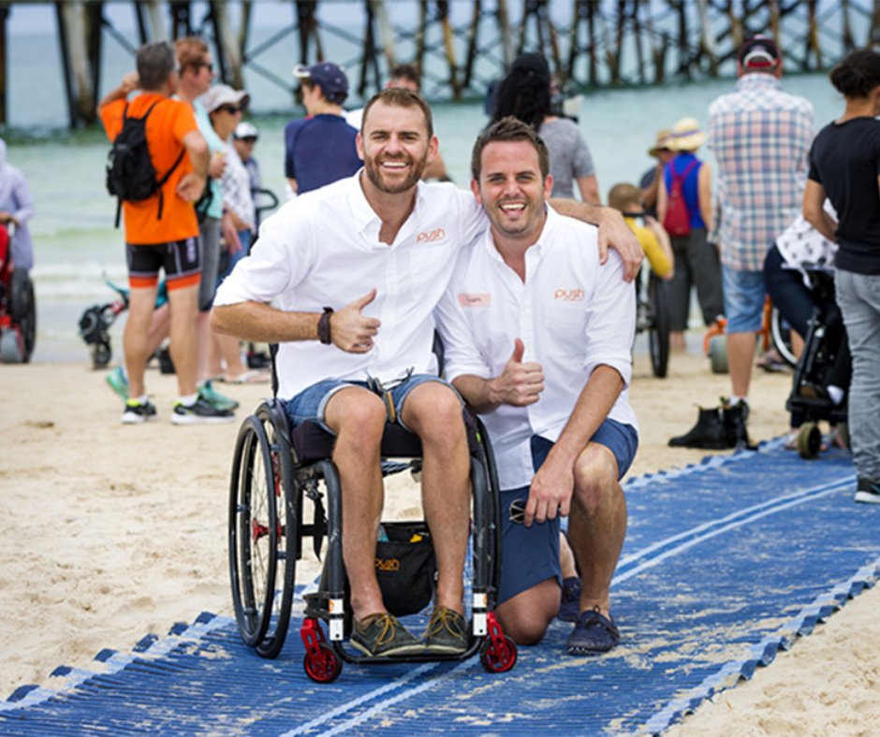

Nikki Hind – Social Impact
Nikki Hind is Australia's first legally blind fashion designer and the Founder of her fashion Blind Grit. Nikki is also the Fashion Editor for Wb40 - Women Beyond Forty Magazine and Magazine, she is a Disability and Inclusion advisor and media consultant. As the Fashion Editor of Wb40, Nikki's passion is to change the around inclusion of disabled people and designers in the fashion industry. Writing features on "inclusive fashion" and why representation of the disability community matters, Nikki is making a powerful impact on how disabled women see themselves, but also changing the narrative on how mainstream media represents disability and fashion.

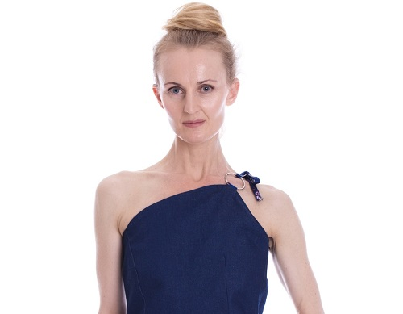

Yasmine Gray – Social Impact
Yasmine and the GetAboutAble team created the 1st Australian tourism destination marketing campaign, promoting Canberra as an inclusive and accessible destination. With financial support from the ACT Government, amazing content was created and promoted that will help dispel perception that the tourism industry can’t cater to access needs, empowering travelers with accessibility needs.

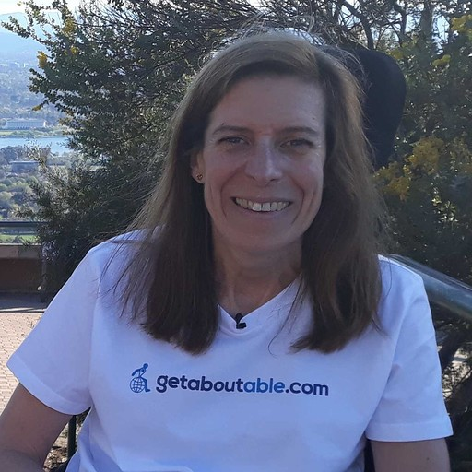

Zac Chu – Social Impact
Zac overcame loneliness & anxiety from family separation & the pandemic lockdowns to emerge from depression & self-pity to convene Diet to Save Earth to contribute towards the attainment of relevant UNSDGs. In recognition of his work at DTSE, he has been invited to represent Australia at COY16 which is part of COP26. He also contributes as a member to a variety of organisations for the disabled.

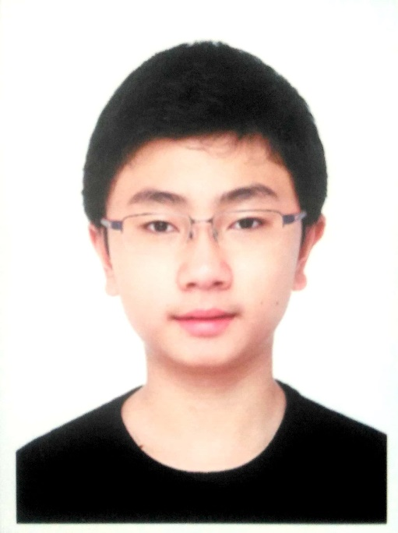

Iain Edwards – Change Making
Iain uses his lived experience of blindness in his current roles to significantly improve outcomes for people with disability in the Health and Disability sectors. His leadership in policy development, disability awareness and best practice quality frameworks has enabled positive change ensuring people with disability receive equitable care, retain choice and control and feel supported and valued.

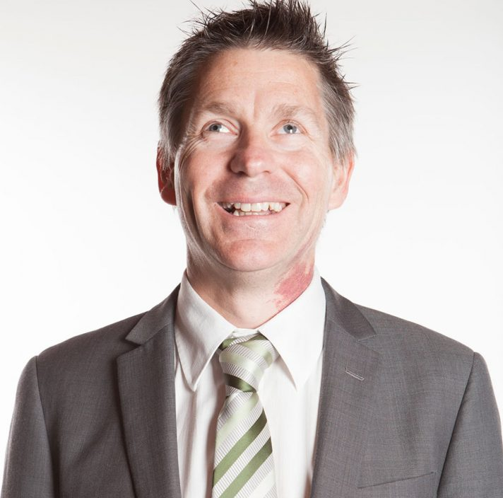

Jenny Smith – Change Making
Jenny is a respected member of the mental health sector and participates in several organisations that have a direct influence on mental health policy. She spends many hours in meetings advocating to improve programs and services for people living with mental illness and there families Currently she sits on over 10 committees, is a peer educator and volunteer.

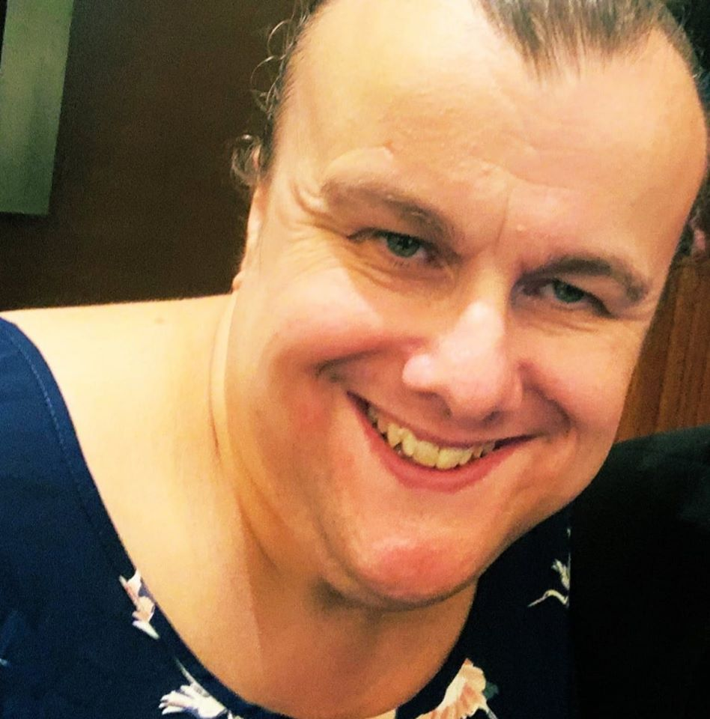

Kimberley Congram – Change Making
Kim worked to reform & transform the inclusion network for people with disability in the Attorney-General’s Department (AGD) & the APS. She redeveloped the Celebrating Ability Network (CAN), growing membership from 0.3% to 11%. Her enthusiasm and leadership has built an environment of support & inclusivity, built trust amongst the cohort, & enhanced inclusion of people with disability & diversity.

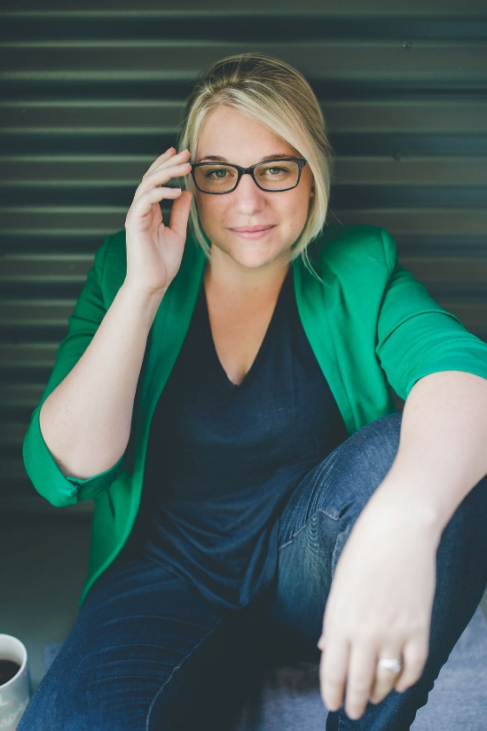

Michael Chan – Arts
Since performing shows with Back to Back Michael has such big dreams and aspirations to follow without hesitancy that brought into misconception about his acceptance and identity. He’s a unique, creative human being who advocates to champion diversity and inclusion – disabled or not – to discover their passion and interest while grappled with living between two different worlds, like himself.

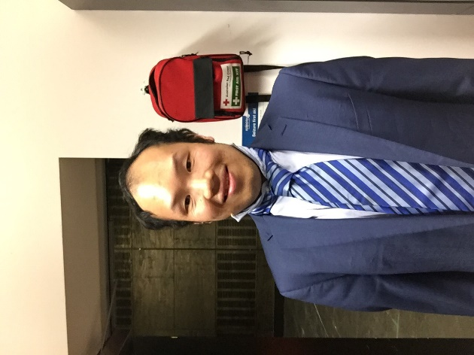

Duncan Steward – Arts
Duncan Steward is the founder and owner of Platinum Cre8ive (an organisation specialising in representation of artists with disabilities in the creative arts sector in Australia and Internationally) Duncan is also the co-creator and organiser of the online International concert WhiteStick Fest.

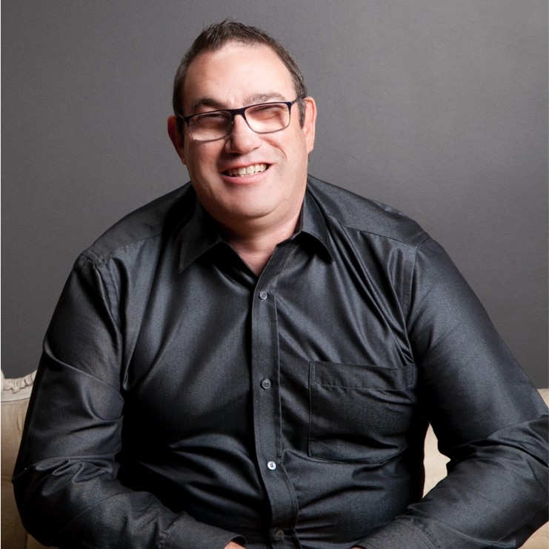

Carol Taylor – Arts
Carol Taylor is a lawyer, award-winning artist, the world’s first quadriplegic fashion designer. In addition she is a disability advocate through both her works as a founding member of the Queensland Law Society Diverse Abilities Network and through her role as a non-Executive Director of Spinal Life Australia. Carol’s designs caught the attention of Mercedes-Benz fashion Festival Director. She was invited to design a collection of 9 pieces of adaptive clothing to open a runway event for Mercedes-Benz fashion Festival. This was a first of its kind for fashion inclusivity, it was the first time an all visible disability cast of models appeared on a national runway.

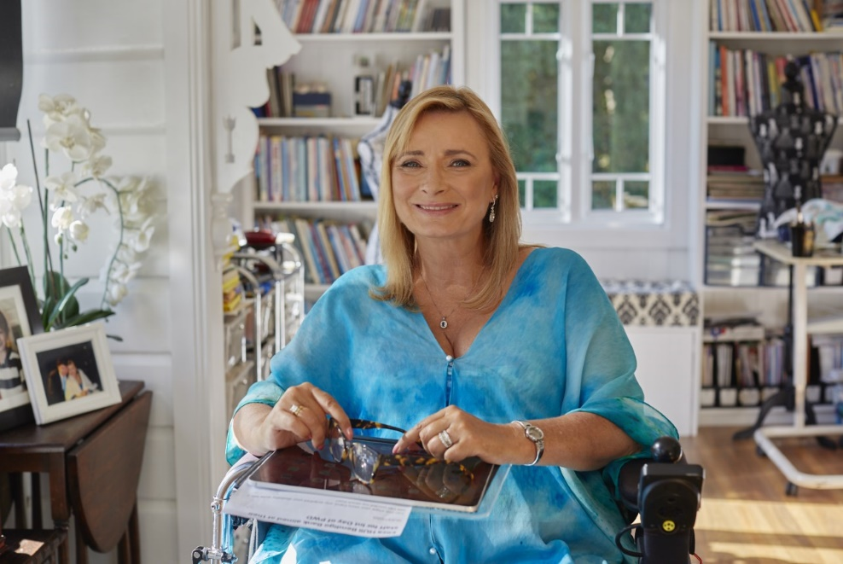

#DisabilityAwards2021

