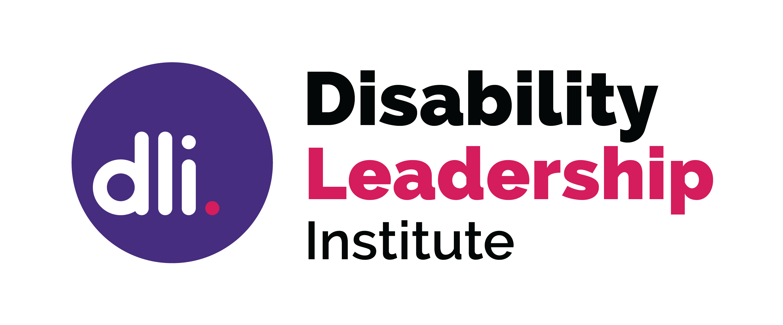

What is the difference between a Resume used for employment and a Board Resume?
The focus of your board resume is your ability to put the interests of the organisation first and to act accordingly, and the governance expertise you bring.
The focus of your employment Resume is on selling yourself, and to highlight your ability to do a particular role in an organisation.
“…your (employment) resume is crammed with (personal) accomplishments … a Board CV … positions you as a strategic and experienced leader and collaborator, ready to guide and advise a company… a holistic view of who you are, and the strengths and values that you — and only you — can bring to the table.

Skills and Knowledge

There are some common items to include in both CVs; however, when applying for a board position you need to change the focus.
While your management, legal or HR experience may be important, boards are not looking at what you can do operationally, but how you can provide governance, strategic oversight, and monitor the organisation.
Your Board role will require you to question all aspects of the organisation – finance, legal, risk, occupational health and safety, ethical framework, and culture.
Think of the Board role as a consultant role, rather than as a management role. Think of the skills that are required on a board and develop your resume around that framework.

- Use the resume to show your uniqueness, why you want to join that particular organisation, why you are passionate about what they do
- The ability to develop a board resume will help you to show your communication
- Use “our’ achievements and teamwork to show that you are able to work collaboratively.
- Indicate how you have been able to compromise to ensure best outcomes.
- Show how you have used active listening to ensure all have an equal voice.

- Use examples of leadership in the workplace to show how that can be used in a board situation.
- Speak of your knowledge and experience of, or passion for the organisation’s work to show your industry knowledge.
- Share your volunteer experience to show commitment
- Share your previous board experiences, what committees you have been on and how you were able to navigate the board culture
- Highlight any board achievements, which might be ensuring gender and diversity are included
- Include your board specific qualifications and experience, so if you have done courses which help you understand fiduciary duties, financial reports, or the legislative responsibilities which come with a board appointment, include those in your resume. Indicate that you can read papers with curiosity, to be able to confidently question what you are being presented with.

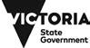

© Disability Leadership Institute 2020

Towards Board Diversity is supported by the Victorian Government

ABN: 31 625 817 272
PO Box 1165
Civic Square ACT 2608
http://disabilityleaders.com.au
engage@disabilityleaders.com.au

https://medium.com/@athenaalliance/what-is-the-difference-between-a-board-cv-and-an-executive-cv-6ad7be540a4b

