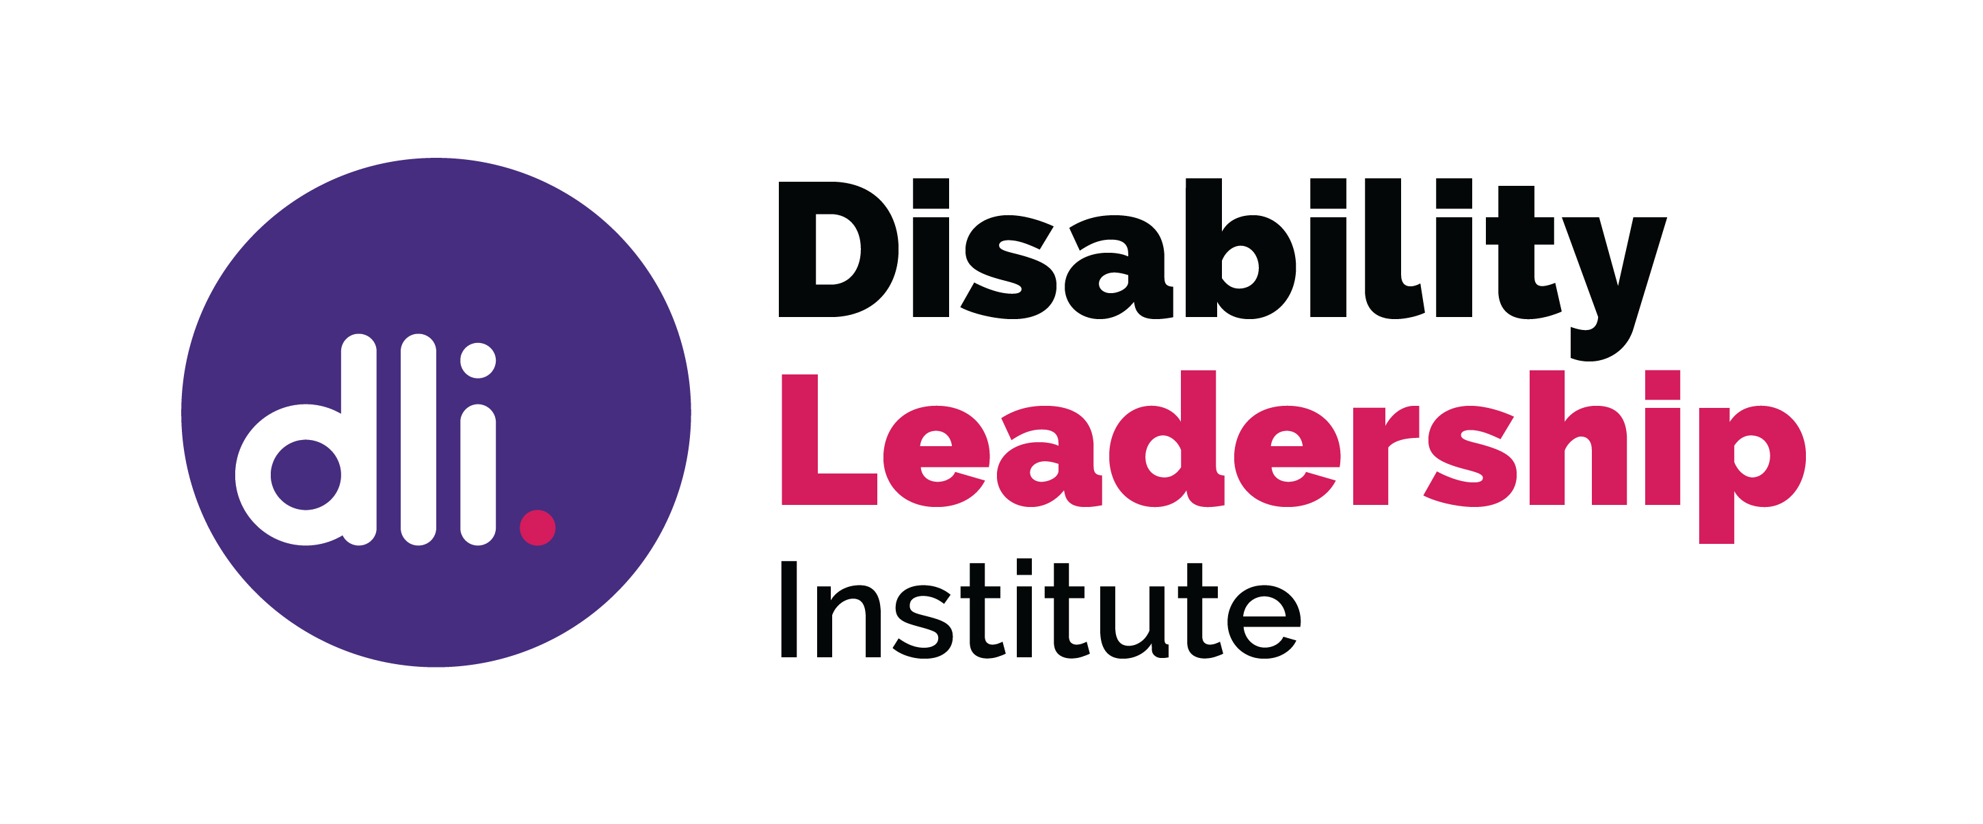

The Role of the Board and the Board Member
“Board members oversee an organisation on behalf of owners, shareholders and stakeholders so you need to be comfortable in your role as a caretaker for the company’s wellbeing – you are acting in the interests of the company and not yourself.”
The key role of the board is governance:
“… the system by which an organisation is controlled and operates, and the mechanisms by which it, and its people, are held to account. Ethics, risk management, compliance and administration are all elements of governance.”
A board has a collective responsibility to provide oversight of the organisation. Board members are expected to understand governance, and to recognise the difference between governance and operational activities.
Board members must understand their Fiduciary Duty and be prepared to exercise that duty by being diligent, capable, honest and proactive. Boards require commitment. Each board member should be aware of the board’s responsibility to decide on the direction of the organisation and to provide guidance to make this happen.

Skills and Knowledge

All governance skills are equally important. Each board member should complement the skills of other board members. Skills may come from qualifications or work history, industry knowledge, or be learned.

Communication skills required – understand confidentiality, be collaborative and communicate appropriately through the Chair or CEO.

Financial skills - the ability to read, understand and analyse financial reports to understand the viability of the organisation and how funds are spent.

Compliance obligations – understand legislative requirements, the Constitution, and governance or board level policies and procedures.

Fiduciary duties – be diligent and act in the best interests of the organisation, so you must be able to question the decisions you are being asked to make.

Culture - each board operates differently and sets its own culture, which influences the culture of the organisation.

Industry or Sector knowledge - understand the work of the relevant industry.

Ethical Framework - the board sets the Vision, Mission and Values for the organisation. This will determine the type of work carried out, how the work is carried out and how funds are spent, including where money is invested.

Risk Appetite – the board is responsible for deciding the level of risk the organisation can take, whether its about how funds are invested, changing the work carried out, expanding the business or taking over another business, and making sure risks meet the ethical framework that the board has set.

Question - be confident to question decisions you are being asked to make, both at the board meeting and when reading the board papers and investigating them prior to a meeting. It is always better to ask questions if you are unsure about what they mean, and to have those questions recorded.

© Disability Leadership Institute 2020

Towards Board Diversity is supported by the Victorian Government

ABN: 31 625 817 272
PO Box 1165
Civic Square ACT 2608
http://disabilityleaders.com.au
engage@disabilityleaders.com.au

https://mangaardpartners.com/24-tips-insights-begin-accelerate-board-career/
https://www.governanceinstitute.com.au/resources/what-is-governance/

