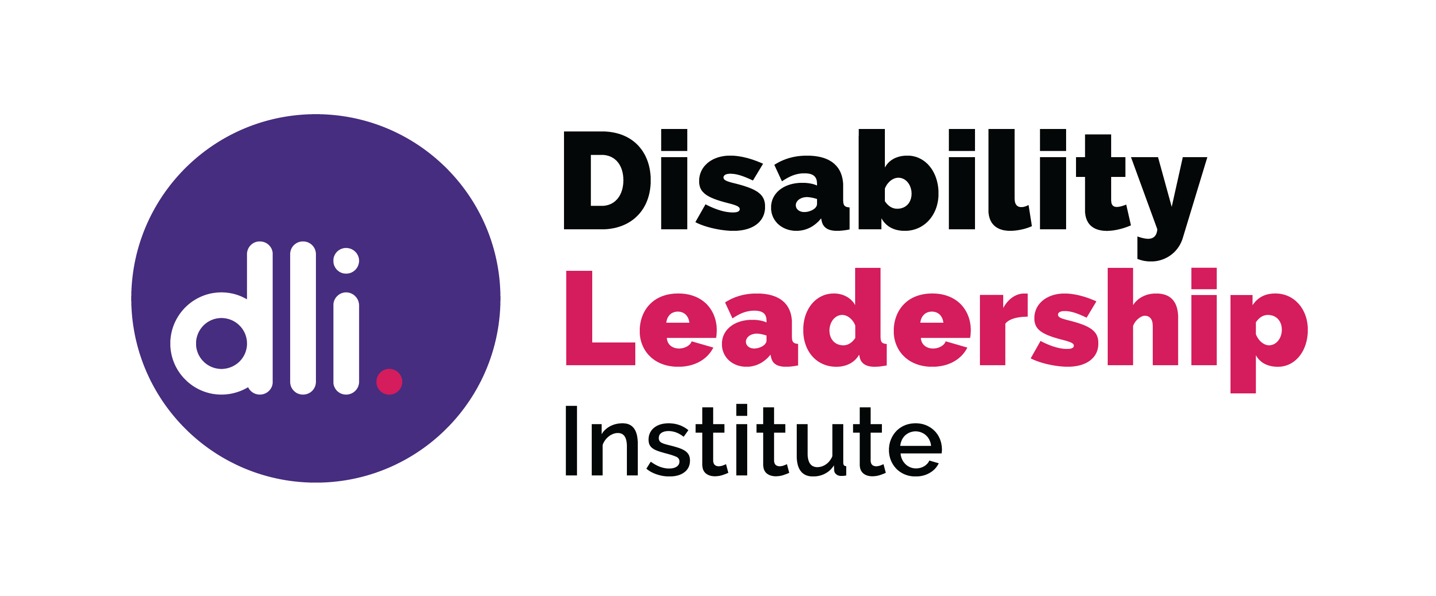

How to describe your transferable skills

“Some … skills will be specific to the industry while others (transferable skills) are those that you can build on and develop throughout your career.”

All of us have skills that we use in both our professional and personal lives. Often we concentrate on our professional skills or qualifications, while losing sight of the skills which are really useful in a board context.

Think about what you already do, and how the skills that you already have could transferrable to a board context.

- Interpersonal Skills are very important to a successful board. They are important to board dynamics and how people work well together, just as they are in the workplace and even in your own family.

- Communication, how you provide feedback on board papers and how you question what you are told. Talk about your communication style and how you use it.

- Active Listening, Board members all contribute equally. Active listening involves being totally involved in what another person is saying. Recognise that all contributions are equal.

- Collaboration, working together to ensure best practice and beneficial outcomes. Working with others is how most of us spend our working lives so use your experience to collaborate effectively.

- Empathy, ensure that you understand the viewpoint of other board members. In an industry context this indicates your understanding of the work of the organisation. Use empathy to build relationships.

- Integrity, each of us has a moral standing. We have our own values that we bring with us, so ensure that this is demonstrated when carrying out board duties.

- Compromise, Board decisions are collective decisions, and sometimes we have to move from a firm stance to a position that will take the organisation forward.

- Curiosity, board members must bring their curiosity. You need to question why a recommendation is made, and to ask if you are unsure.

- Courage, sometimes you need to go against the flow. If you don’t agree with a recommended decision, then have the courage to speak up, even if others don’t agree. Think of times in your workplace, or community, when you have questioned a decision.

- Flexibility, board members need to be flexible, to listen to arguments and be prepared to change their opinion. Think of your experiences with change and how you have been able to adapt.

- Leadership, all members of a board are expected to show leadership. Which roles have provided you with leadership experience, both formal and informal?

© Disability Leadership Institute 2020

Towards Board Diversity is supported by the Victorian Government

ABN: 31 625 817 272
PO Box 1165
Civic Square ACT 2608
http://disabilityleaders.com.au
engage@disabilityleaders.com.au

https://www.wikijob.co.uk/content/interview-advice/competencies/transferable-skills

