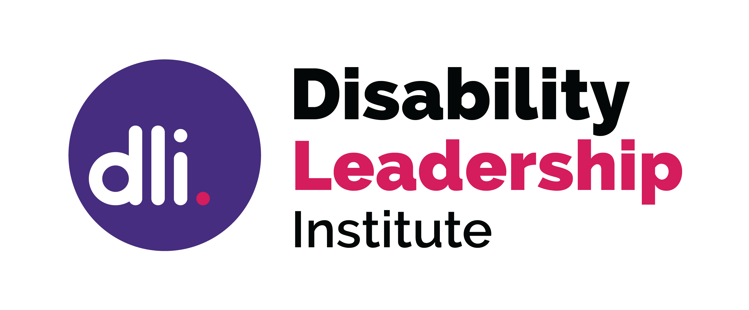

Getting on a Board – How to get started

Do a little research and ask some important questions about whether this board will be a good fit for you and the board.
Getting on the right board is important.
Check with your networks of friends and colleagues. Look at organisations you are interested in.
Have discussions with people who work in the industry sector you are interested in, or who are already on a board as they may have useful information.

Why a Board?
There are a number of reasons you may want to join a board. You may want to improve an organisation, to learn, to influence, have a personal connection to the industry, or you just want to be involved in how decisions are made. All of these are valid reasons.

Which Board should I join?
Boards vary from industry to industry, and it is important that you look at organisations that you are interested in. Also consider what the board is looking for. If you have a passion for a particular sector you might like to look at joining the board or committee at a school, a health service, a gardening club, or any not for profit organisation, large or small. Look at your existing networks and interests.

How do I make sure we match?
Do some research, look at the organisation’s website, check out who else is on the board, have a look at their annual reports. Make sure the organisation meets your ethical standards. If they are advertising for a vacancy, look at the skills they are seeking. Contact the chair and talk to them about the organisation and the board culture. Don’t be afraid to ask questions.

How do I find a Board vacancy?
Some people find it is easier to go on a board search website or to get on a mailing list. Others talk to people in their networks to help find the board they want. Most of us know someone who is on a board, so talk to them about how they found the right board. You may find that they know of a vacancy that is coming up.

What Can I offer?
Formal skills are important; however, the important skills for a board include industry knowledge, the ability to work collaboratively, examine board papers with a questioning mind, active listening, and time. Most boards have a skills matrix which will help match skills gaps. Think about the skills you have to offer.

© Disability Leadership Institute 2020

Towards Board Diversity is supported by the Victorian Government

ABN: 31 625 817 272
PO Box 1165
Civic Square ACT 2608
http://disabilityleaders.com.au
engage@disabilityleaders.com.au

https://www.boardeffect.com/blog/choose-right-board-first-time-board-members-know/

