Skills you use
every where

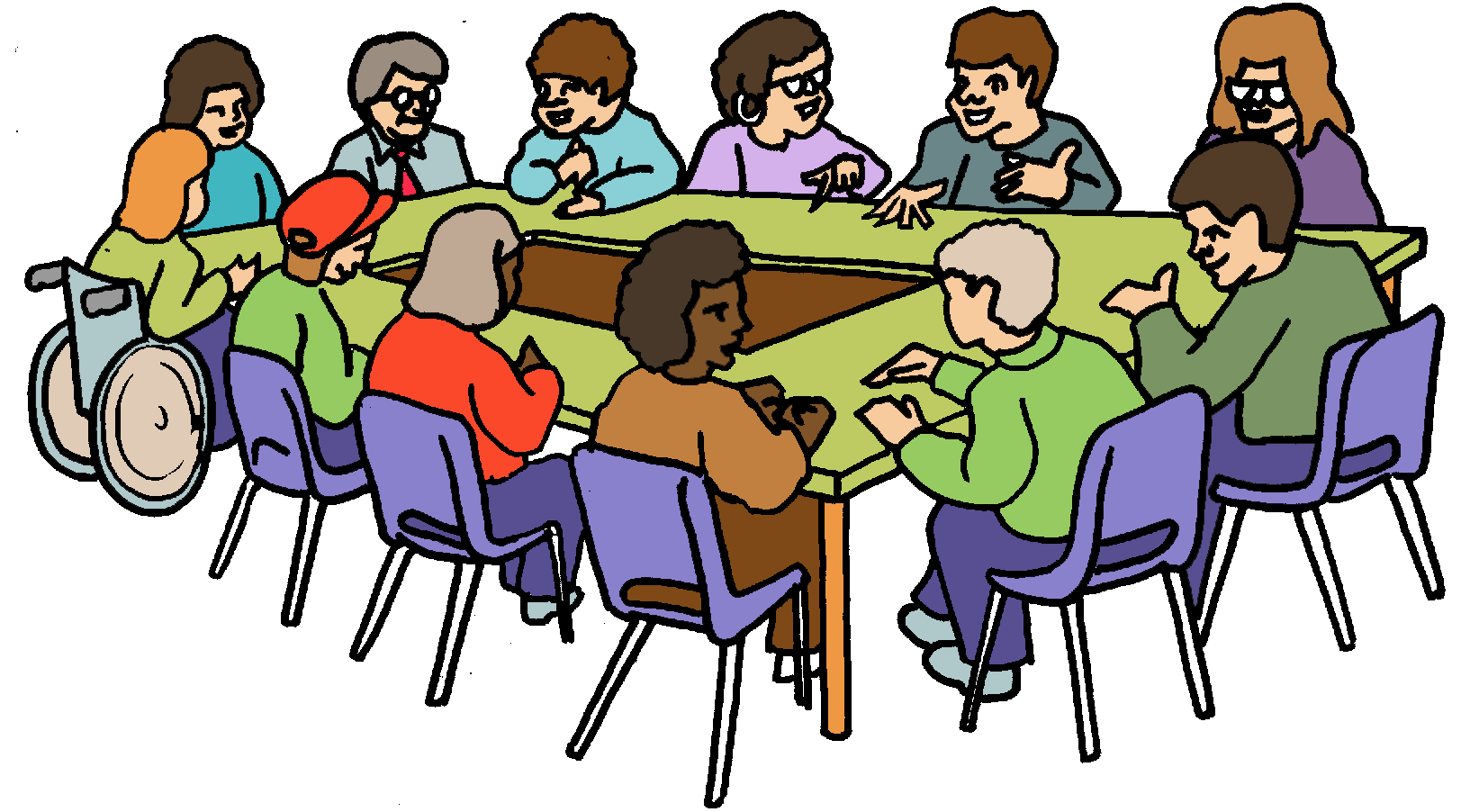
You want to join a Board

You need to write about your skills.
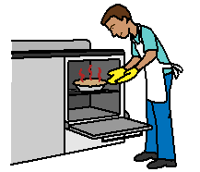
There are the skills to do your job. Like
- the steps to make a cake
- the steps to write a plan.

But

You have lots of other skills too. You use these skills
- in your job
- in your local area
- with your family
- with your friends.

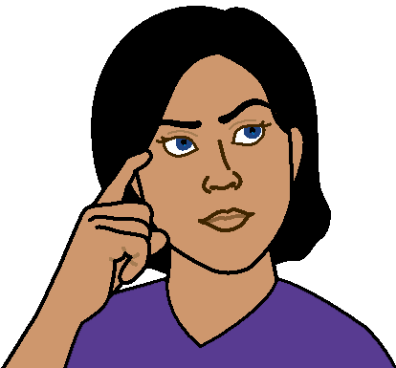
Think about all the things you do in your life.

Tell the Board what you do
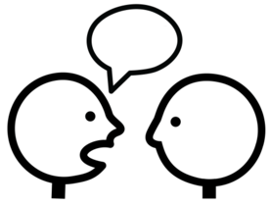
- When you work with other people. Like
- listen to what people say
- ask what people think.
They are called interpersonal skills.

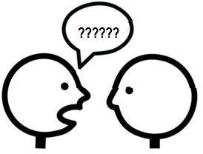
- To find out more information. Like
- do you ask lots and lots of questions?
- do you look for information from other places?
We all do this differently. That is ok. The Board need people who are different. It is called your communication style.
Tell the Board what you do.
- To listen to other people. Like every person has a turn in making a plan. This is also called
active listening.

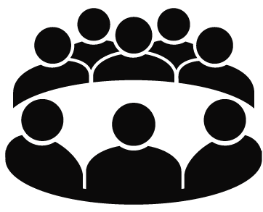
- To work well with other people. Like
- meet in a group

- meet with just one person at a time.
This is also called collaboration.

Tell the Board what you do
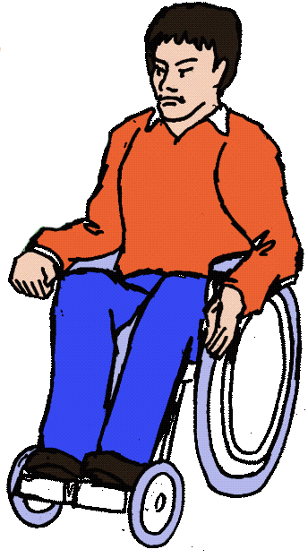
- To understand other peoples view. Like
- you are in a wheelchair
- another person is blind.
You listen to the person who is blind.
It helps you understand how he may do things
in a different way.

And

- you are also a boss. You know it is important that the job gets done on time. You need to understand what a person needs to do the job.
This is called empathy.

Tell the Board what you do
- To make choices based on what you believe. Like
Every one gets a fair go.
So all the men can try to do a new task.
All the women can also try to do the new task.
This is also called your integrity.

- To change some of your decisions to fit with the
rest of the team. This is called compromise.

- When you want to find out more
- in a meeting
- a new idea.
This is also called curiosity.

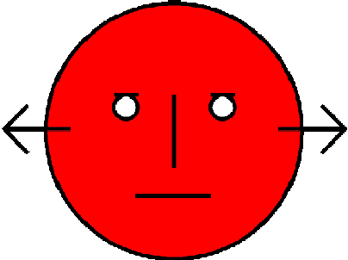
- When you do not agree with the decision a
group makes. Tell the Board how you let others know you do not agree.

You can say how this makes you feel. You may say you feel brave. It is also called courage.

- To get some one to change their mind.
You also need to listen to the other side.
This is called flexibility.

- To be a leader. Think about how you do good things
- at work
- in your local community
- at home.
This is called leadership.
More information

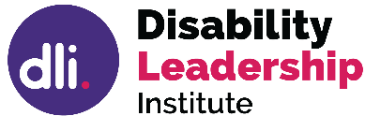
© Disability Leadership Institute 2020
Towards Board Diversity is supported by the
Victorian Government
ABN 31 625 817 272

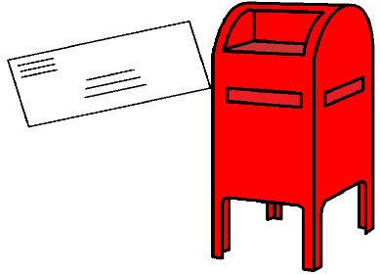
PO Box 1165
Civic Square ACT 2608

http://disabilityleaders.com.au
engage@disabilityleaders.com.au

Images
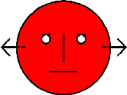
We used images from
- COMPIC
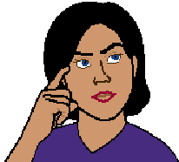
- InspiredServices
- Mayer- Johnson
- Picto-Selector
- TheNounProject.

This fact sheet is based on the Disability Leadership Institute fact sheet How to describe your transferable skills. June 2020.

Access Easy English wrote the Easy English.
June 2020.

