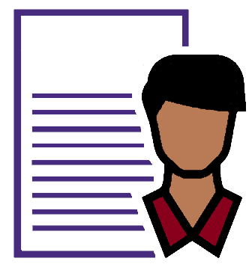
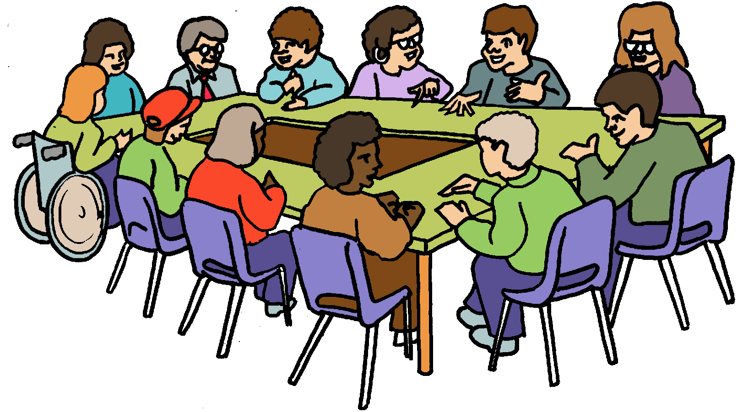

How to talk about your skills
We call this a Resume

You want to join a Board

You need to write about what you can do.
It is called a Resume.

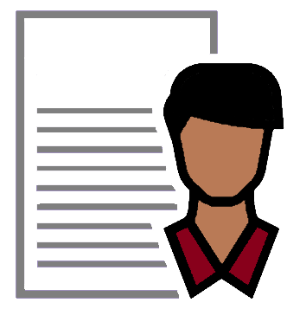
You did a resume when you looked for jobs.
This was your Job Resume.

You need to write a resume for the Board.
This is called your Board Resume.

Your Board Resume

This is not a Job Resume.

Your Board Resume will say what you are good at.

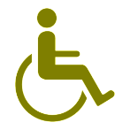
This Resume will tell the Board about your skills. Like
- how you work well with others
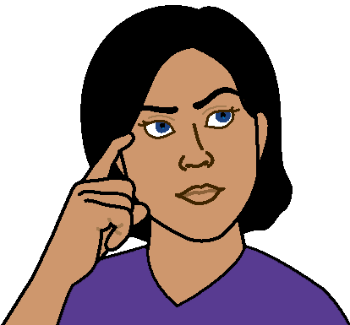
- how you tell others what is good or bad
- that you can think of new ideas
- you understand what needs to happen to make the organisation better.
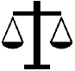
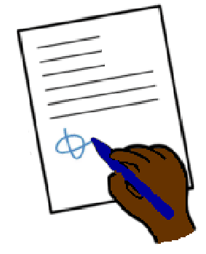
It will also tell the Board you know about
- what government rules mean for the Board
- what you know about the laws for this organisation

- the way you work with other people
- what is important to you. These are called
your values. Like
- respect. Every one must treat each other well
- kindness. Every one must be kind to each other.

Your resume also needs to say that you understand
- the need to plan the use of money
- there are risks in how money is used.
- to make money is a good goal.

It will also say
- what you think about safety at work
and
- what can be done to be more safe at work.
- how you work out when a job is OK for staff to do. This is also called risks.
This is all called Occupational Health and Safety.

Things you can write in your
Board Resume

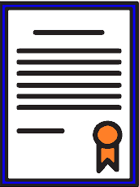
- Write the courses you have done. Like
- training courses
- your school
- TAFE training
- university courses.

And

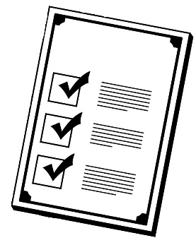
The Board wants to know more about what
you think about
- planning
- big ideas
- how to know staff are doing things the right way.
- Tell the Board what is different about you. It may be
- what you know about this business
or
- you have been on other Boards.
It helps to have lots of different people on the Board.
This is called diversity.

- Good communication
The Board wants to know how you tell people things.
And
The way you put information together. They want to see how you write or record your Board Resume. Like
- it is clear
- easy to read
- so the reader can understand
and
- know what skills you are good at.
- Tell stories from your life about
- how you work well with other people.
This is also called collaboration
- how you changed some thing to make it better
for every one. This is also called compromising
- how you listen to other people. Like you check every person has a turn to talk at the meeting.
This is also called active listening.

- Tell a story about when you lead a team of workers. This is called leadership.

- Write about the things you know about this
sort of organisation. Like you want to join the
Board of a Sports Club. Talk about what you
- like about that sport
- why it needs to be important to more people
- what you may have seen in other places.

- Write a list of other places you have worked.
Also write any places you have done volunteer work
Like 4 hours each week at the school library.

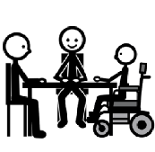
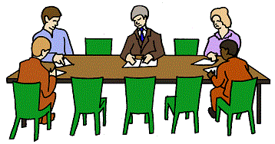
- Write a list of
- other Boards you have been on
- other committees you have been on.

- You can tell a story about how you
- worked with the other Board members
- made people think of things that need to change. Like
- to have more women on the Board.
or
- to have more people with disabilities
on the Board.

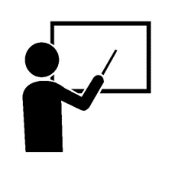
- Write a list of any courses you have done
that help you be a Board member. Like
- how to read the pages about money
- the laws a Boards need to know.

More information

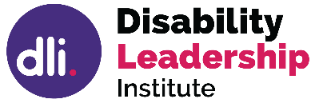
© Disability Leadership Institute 2020
Towards Board Diversity is supported by the
Victorian Government
ABN 31 625 817 272

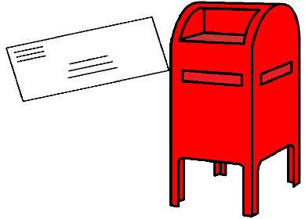
PO Box 1165
Civic Square ACT 2608

http://disabilityleaders.com.au
engage@disabilityleaders.com.au
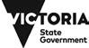

Images
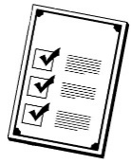
We used images from
- ChangePeople
- COMPIC
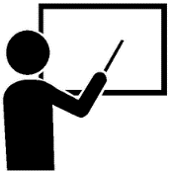
- InspiredServices
- Mayer- Johnson
- Picto-Selector
- Spectronics
- TheNounProject.

This fact sheet is based on the Disability Leadership Institute fact sheet What is the difference between a Resume used for employment and a Board Resume? June 2020.

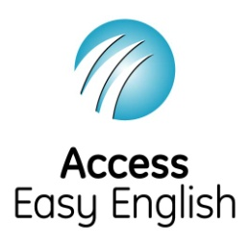
Access Easy English wrote the Easy English.
June 2020.

