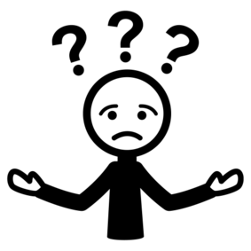
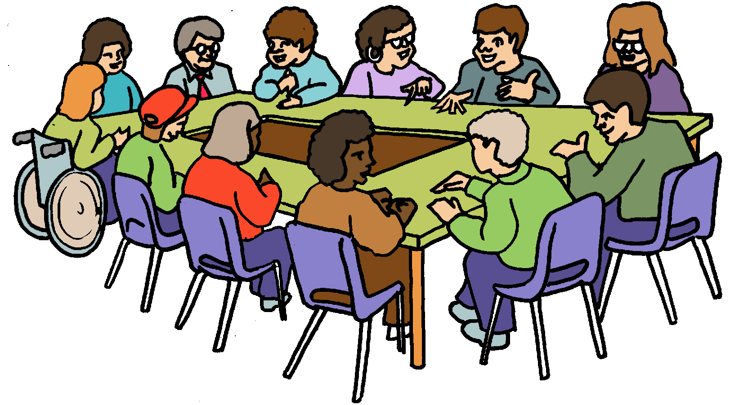

Boards.
What do they do?

What is a Board?
?

It is a group of people. They set the rules.
People on the Board are called Board members.

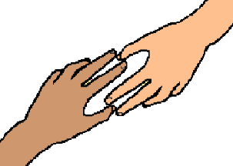
Together they look after an organisation.

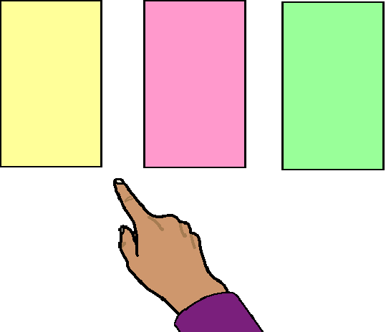
They need to make big choices.
These are called decisions.

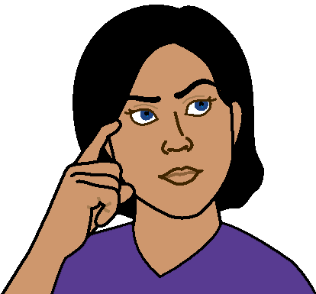
They need to think about what a decision does for
- the people who own the organisation
- the staff
- the people who give money to the organisation
- the people who come to the organisation. Like
- people that use its services
- people who buy things.

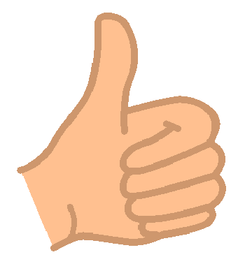
Board members need to work out
what is best for the organisation.

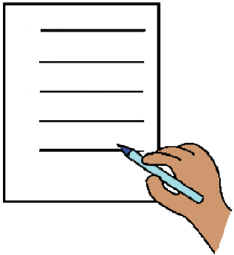

Board members have lots of rules to help them.

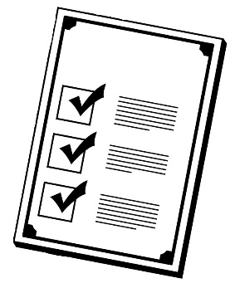
The Board checks everything runs the right way. Like
      - there are rules to keep every one safe
      - there are steps the staff follow to stay safe.

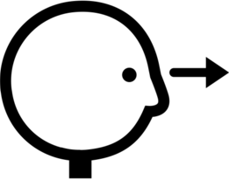
Board members are not staff. Staff do the jobs
in the organisation. The Board members look at
      - how different parts of the organisation work together
      - the rules the staff must follow
      - how money is spent.

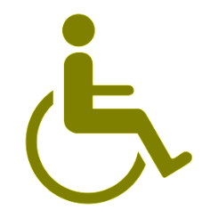
There are lots of different things Boards need to do.
Different Board members have different skills.
This helps the Board do its job.

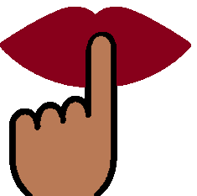
- Communication
Board members hear lots of different information at their meetings. They do not share this information with other people.

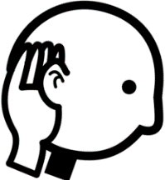
Board members meet lots of different people.
They must be able to
        - listen to other people
        - hear other ideas

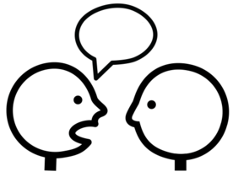
        - talk about what they know in a clear way
        - work with other Board members.

Board members must know who they can talk to. Like
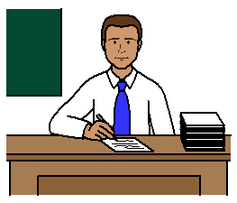
        - the boss of the organisation.
They are called the Chief Executive Officer.
They are also called the CEO
or
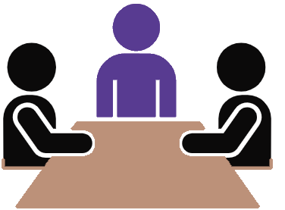
        - the person who looks after the Board.
That person is called the Chair.

- Money
Each month the Board gets a report about money.
Board members need to
        - read the report
        - understand what the report means
        - decide when a new idea is good use of money.

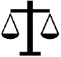
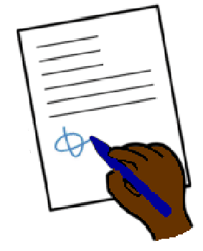
- Board members need to know about
        - laws for the organisation. Like work place safety
        - laws for the Board. This is called the Constitution
        - how things are done in the organisation.
These are the policies and procedures.
This is called compliance.

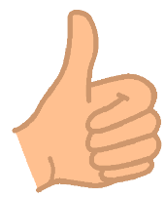
- Board members must make decisions that are best for the organisation. They must
        - ask questions about reports from staff
        - always think about what is best for
the organisation.
This is called fiduciary duties.

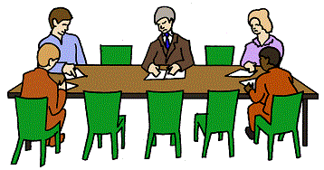
- All Boards are different.

But

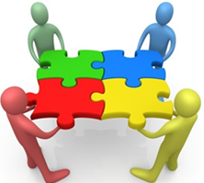
Their work decides how the organisation must work.
This is called its culture.

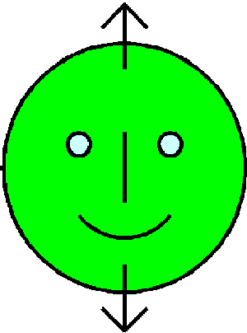
- Board members need to know about the work
the organisation does. Like
        - looks for jobs when you have a disability
        - sells clothes
        - makes big buildings.
This is called sector knowledge.

- The Board makes decisions about
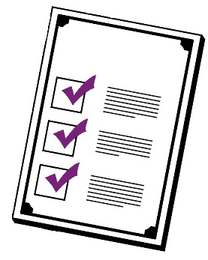
        - where they want the organisation to go. This is looking into the future. It is called the vision
        - how the organisation does things.
This is called the mission
        - how the organisation supports human rights.
This is called the values.

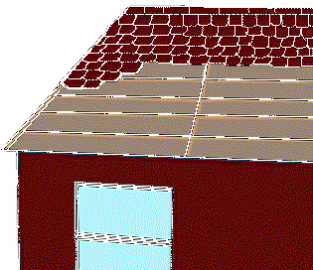
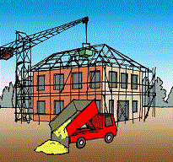
These help to work out
        - what work is done
        - how the work is done

and

        - how money is used.
All this together is called the Ethical Framework.
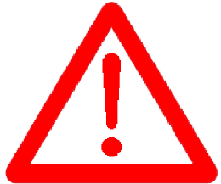
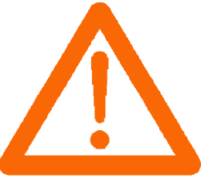
- The Board needs to make big decisions.
They need to decide
        - when to change what the organisation does
        - who is the CEO
        - when to join with another organisation.
This is called the risk appetite.

- Board members must ask lots of questions.
They must
        - find out more about a report before a meeting
        - ask about reports in meetings
        - write the questions in the meeting minutes.

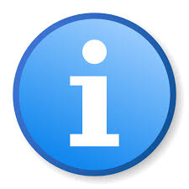
More information

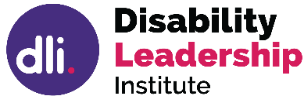
© Disability Leadership Institute 2020
Towards Board Diversity is supported by the
Victorian Government
ABN 31 625 817 272

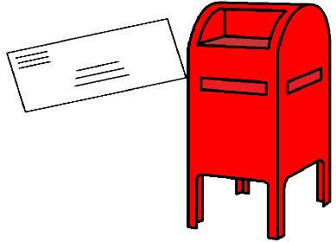
PO Box 1165
Civic Square ACT 2608

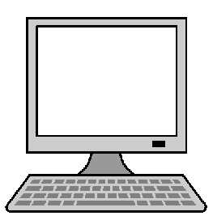
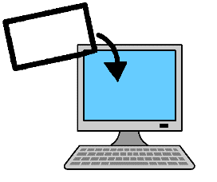
http://disabilityleaders.com.au
engage@disabilityleaders.com.au

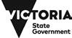

Images
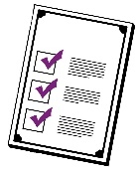
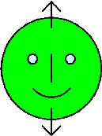
We used images from
- ChangePeople
- COMPIC
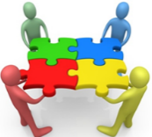
- Google Clipart
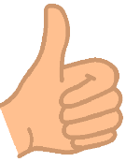
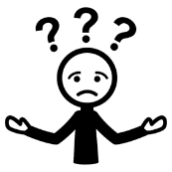
- InspiredServices
- Mayer- Johnson
- Picto-Selector
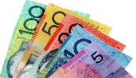
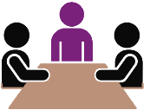
- Spectronics
- TheNounProject.

This fact sheet is based on the Disability Leadership Institute fact sheet The role of the Board and the
Board Members. June 2020.

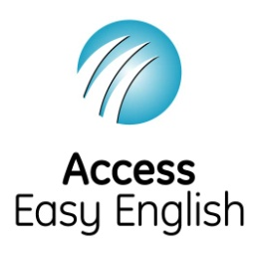
Access Easy English wrote the Easy English.
June 2020.

