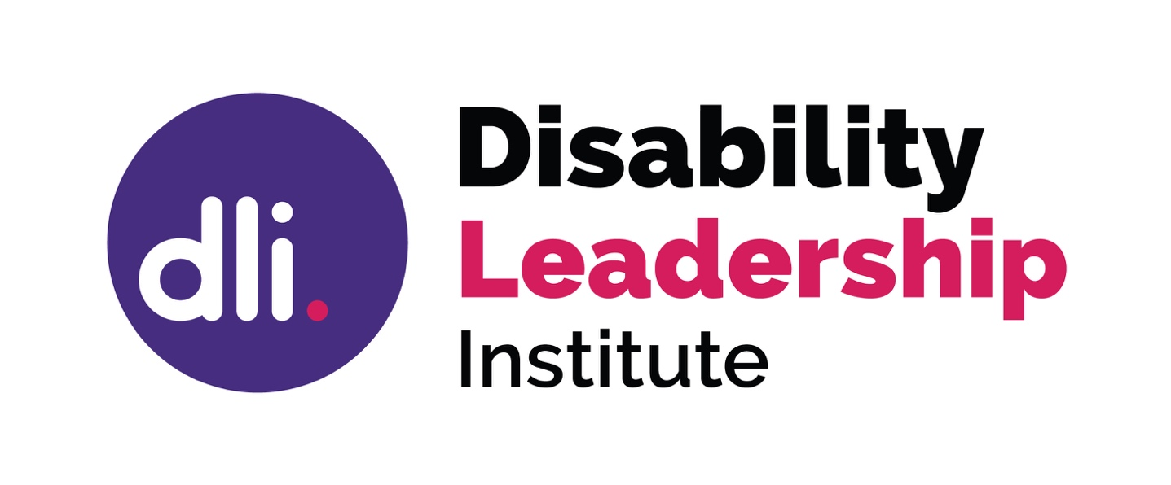

2020 Member Guide

Develop, Support, Promote –

Disability Leaders

Contents

Your membership

5. Introduction

7. Membership

9. Leadership Stage

10. Monthly Member Groups

10. Member Community

11. National Register of Disability Leaders

11. Online Courses

12. Promotion

13. Entrepreneur Co-discovery Sessions

13. Entrepreneur Members Community

How to engage with us

15. Using the Members Community

16. Using Zoom

17. Using Thinkific for Online Courses

18. Social Media

Who we are

21. Develop, Support, Promote – Disability Leaders

21. Christina Ryan

22. Why a Disability Leadership Institute?

Introduction
Welcome to the Disability Leadership Institute! The brainchild of Christina Ryan, we are here to stand beside you on your leadership journey.

This Member Guide is the main resource for understanding and using the many benefits of understanding and using your Premium or Entrepreneurs Membership. Please store it somewhere safe and refer to it frequently whenever you have questions. The Guide is also on our website under Publications. If you need further information you can email the DLI Team at engage@disabilityleaders.com.au.

There are two major benefits to your membership:

Monthly Member Group
and
Members Community.

See page 9 for more information on the Monthly Member Groups & Members Community

We look forward to your leadership journey with us!

I

Your Membership

‘It’s so good to share with others like me!’
- Member, 2019

Membership

Membership is open to all disabled people everywhere.

Starter Membership: A place to start
Starter membership is designed to keep you in the disability leadership loop. If you are new to the idea of disability leadership and curious to know more, this is the perfect window to see what is going on at the DLI.

Starter Membership Benefits:
- Listing on the National Register of Disability Leaders
- Regular (weekly) member only e-bulletins
- Receive news and opportunities from the DLI

Premium Membership: Where your leadership development happens
Premium Membership gives you the space and opportunity for meaningful disability leadership, whatever your leadership experience.

Premium Membership Benefits
- Monthly Member Groups
- Online Members Community

- Free access to DLI online courses and webinars
- Promotion by us across various social media channels

- All the benefits of Starter Membership

Entrepreneur Membership: a place for business innovation and support
Entrepreneur Membership offers a targeted space for those members running their own business. Together they can discuss, share, and problem solve the aspects of leadership unique to entrepreneurship

Entrepreneur Membership Benefits
- Access to Disability Entrepreneurs monthly Co-discovery Sessions
- Access to Disability Entrepreneurs members community
(on Facebook)
- All the benefits of Premium Membership

Leadership Levels
When you join the DLI we ask how you identify as a leader, so we can make sure you receive the right resources and information.

Tell us what level best represents your leadership?

- Just getting started in my leadership work
  - You are new to leadership
  - You are looking to develop the skills you will need

- Consolidating my skills and getting confident at using them
  - You have been working on your leadership development for a while
  - You want to start using the skills and expertise you have gained

- Stepping up to the next level of leadership
  - Your leadership career is well under way
  - You likely have a team or network looking to you for leadership
  - You are recognised as a leader
  - You are asked to be involved because you make a difference

- Experienced leader wanting to connect with other experienced leaders
  - Your leadership career is advanced
  - People look to you for guidance
  - You are mentoring others
  - You put your time and energy into the development of others
  - You rarely put time into your own development
Premium Member Benefits
Monthly Member Groups
Be part of a group of leaders who are at a similar stage of leadership development to you. Meet virtually, online, each month at a time that suits you to connect, share, trouble shoot and support.

All Premium and Entrepreneur Members can participate in DLI Monthly Member Groups. When you sign up, you let us know your leadership level. We use this information to match you with your peers so that your group works for you.

See page 14 for how to use Zoom to participate in Member Groups

Members Community
The DLI Members Community is an email discussion group and one of the major benefits of your Premium or Entrepreneurs membership.

It is a safe place to discuss leadership, share what you have been reading, help solve problems, and talk about your own leadership work.

National Register of Disability Leaders
The National Register of Disability Leaders is Australia’s first, and only, national register of disability leaders seeking appointments to various positions, including boards, committees and paid employment.

All members, at all levels, are automatically added to the Register. You will be notified of opportunities as they arise, based on your location.

Online Courses
Online learning at a time that suits you.

The DLI provides a suite of leadership courses and webinars open to anyone who wishes to participate.

For information on how to access our online courses, see page 15. DLI Premium and Entrepreneurs members have free anytime access. Use your personal member code to gain access.

Promotion
The DLI promotes the success of our Premium and Entrepreneurs Members at every chance.

Just provide your social media handles to our Community Coordinator so we have the ability to share your successes. We set up an alert for each member to keep track of the great work you are doing.

Entrepreneurs Membership Benefits

Entrepreneurs Members Community
The Entrepreneurs Facebook group is the primary discussion community for DLI Entrepreneur members.

Share knowledge, ideas, ask questions and trouble shoot in a safe space with other disability entrepreneurs.

Entrepreneurs Co-discovery Sessions
Entrepreneurs members are welcome to join our monthly Co-discovery Session. Each month Entrepreneurs share knowledge, ideas, ask questions, about the topic under discussion.

The topics are centred on business practice and are decided by discussions in the Entrepreneurs member Facebook group. The Sessions are recorded and available for free anytime access via our online courses.

See page 14 for how to use Zoom to participate in Co-discovery Sessions

How to Engage with US

‘Can’t thank you enough for your valuable resources and remarkable support for Disability leaders.’
- Member, 2019

Members Community
The Member’s Community is open to all DLI Premium and Entrepreneur members. When you join, you will automatically be added to the Members Community, and email discussion group – the Google Group ‘Disability Leadership Institute members community’.

How to participate
To ask a question or start a discussion, simply write an email and address it to:
disabilityleaders@googlegroups.com
To comment on an existing conversation, just hit reply to an email.

Who are you talking to?
All Premium and Entrepreneurs members of the DLI have access to the community. This means when you start a conversation or reply in an existing conversation, all of our Premium and Entrepreneurs members can see what you have sent.

Why Email?
The DLI use an email discussion group for reasons of accessibility. We asked members what would work and this is their platform of choice.

Email Options
You will receive emails routinely – these are ongoing discussions. If you would like to receive a single daily summary email just ask us. Contact us at engage@disabilityleaders.com.au to request this.

Using Zoom
The DLI uses Zoom for Member Groups, Entrepreneurs Co-discovery Sessions, virtual meetings and live webinars. To participate you need a computer or smart device (e.g. tablet, phone) that has an internet connection, a built in or external camera, and a microphone.

How does it work?
Ahead of a meeting or webinar, we will send you a ‘Zoom Invitation’. As well as the time and date, this invitation will contain:
- a link to automatically join the meeting
- a unique Meeting ID (9, 10, or 11 digit number)
- a teleconferencing number
Topic: Sample Zoom Invitation
Time: Feb 1, 2019 1:30 PM Canberra, Melbourne, Sydney
Join Zoom Meeting
https://zoom.us/j/189420256
Dial by your location
+61 2 8015 2088 (AUS)
+61 8 7150 1149 (AUS)
Meeting ID: 189 420 256

Connect using Email:
- Join by clicking on the URL Link in your e-mail or calendar invitation
- You will be prompted to download and run Zoom the first time you use it, allow this to happen
- Join meeting using computer audio

Connect through the Web Browser
- Go to join.zoom.us in any browser (Chrome, Firefox, Safari, etc)
- Enter your meeting ID from the Zoom invitation and click ‘Join’
We ask that you use headphones or earbuds to prevent echoes.
Using Thinkific for Online Courses
The DLI uses the Thinkific platform to host our Online Courses and webinars. Before taking your first course with DLI, you will need to create a Thinkific user account. You will be prompted to create an account when you begin the enrolment process.

Enrolling in a DLI Course
- Select your chosen DLI course at: https://disabilityleaders.com.au/disability-leaders/online-courses/
- Create a Thinkific account, or log in to your existing account.
- Select a payment method, input credit card details, and confirm the purchase.

Premium Member Codes
Premium and Entrepreneurs members receive free access to DLI Online Courses. To access courses for free follow the above steps. When you come to payment options, select ‘DLI member? Insert your personal code’. Select purchase to access the course for free.

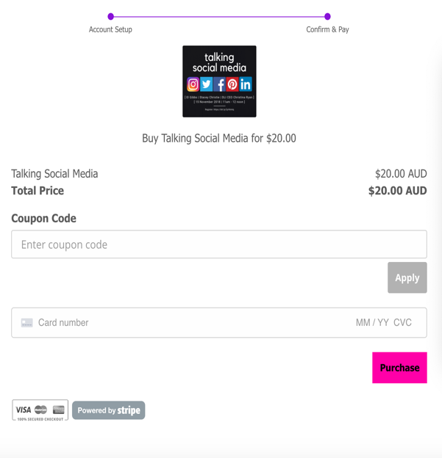
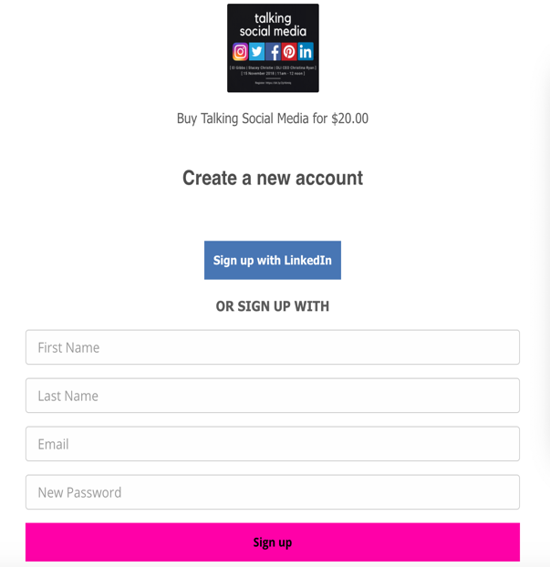

Social Media
One of the ways we stay in touch with you and promote our members is on social media. Join us to hear more about funding and job opportunities, relevant articles and links, and to stay up to date with the achievements of your peers.

Facebook – DLI Page
https://www.facebook.com/disabilityleadershipinstitute/
Where we promote our premium members, share out latest news and share links to interesting articles.

Facebook – Disability Entrepreneurs Page
https://www.facebook.com/DisabilityEntrepreneurs/
Where we share content that is relevant to disability entrepreneurs and news about our entrepreneurs work.

Facebook – Global 15 Percent Campaign Group
https://www.facebook.com/groups/451271125231428/
Where we invite you to join us in creating a world where 15% of leaders are disability leaders.

LinkedIn – Page
https://au.linkedin.com/company/disability-leadership-institute
Where we promote our premium and entrepreneurs members, share news and share interesting articles and career opportunities.
Twitter
@DisabilityLead https://twitter.com/DisabilityLead
Where we keep you up to date with the latest in Disability Leadership, read interesting articles and see the latest news.

Instagram
@disabilitylead https://www.instagram.com/disabilitylead/
Where we share the latest news from the team and share opportunities from our friends.

Pinterest
https://www.pinterest.com.au/disabilityleaders/
Our library, where we save all our favourite articles and resources.

Keep in touch with us, and with each other!

#Global15Percent
#WeAre15Percent

Who We Are

‘This is a safe place to share these things.’
- Member, 2019

Support, develop, promote –Disability Leaders
The Disability Leadership Institute has been established by leaders with disabilities for leaders with disabilities. It is time to change the way leadership is understood.

We do things differently by looking at leadership through a disability perspective, and by acknowledging the specific attributes of disability leaders. We use this perspective to develop our programs, short courses and webcasts so that you have access to the latest in leadership development without encountering ableism and discrimination, while also using your disability to enhance your leadership style.

Christina Ryan
Christina Ryan is the CEO and Founder of the Disability Leadership Institute.
She has been an active leader in the Australian disability community working to change the diversity agenda.
Christina has identified and named Disability Leadership and is the pioneer behind this growing field.
To find out more visit:

https://disabilityleaders.com.au/global15percent/about-dli/
Why?

Disabled people make up 15% of the global population. This is over 1 billion people.

Disability is often forgotten in diversity discussions.

DLI members come from over 20 countries across an array of industries.

Disability Leaders are operating almost entirely under their own resources and within their own circles of engagement.

Many established leaders are regularly mentoring several emerging leaders to ensure some continuity and succession planning for leaders with disabilities over time.

