The Absence

Report on

Westpac Social Change Fellowship

Christina Ryan

February 2018

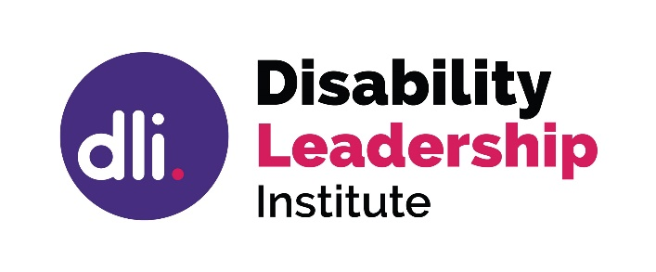

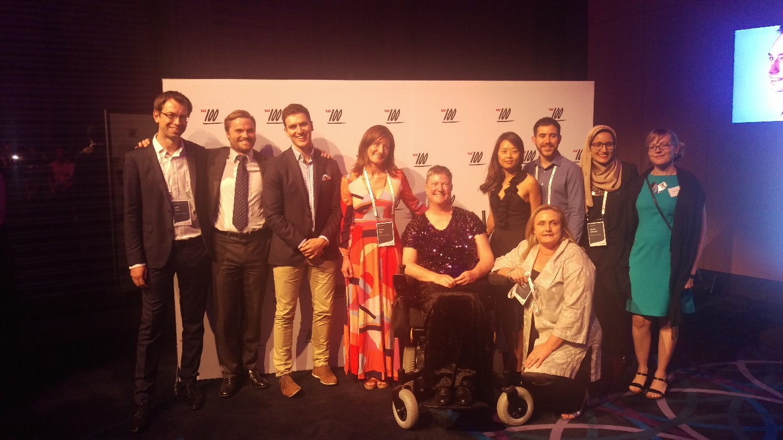
The 2017 Westpac Social Change Fellows (l to r: Luke Terry, Chris Raine, Jordon O’Reilly, Sarah Gun, Christina Ryan, Julia Suh, Nick Maisey, Naba Alfayadh, Karen Wellington (2016), Bronwyn Sheehan (kneeling). Absent: Chris Ennis.)

Discoveries and understandings

My Westpac Fellowship was a unique opportunity to uncover what is happening in disability leadership. How does disability fit into the diversity space, how is it being wrapped into other diversity programs and what is being done to target and develop leaders with disabilities? Additionally, I wanted to understand what has worked, not worked, been considered, in other diversity areas to ascertain if it is translatable to disability, or perhaps to be forewarned about what to avoid.

I targeted the major corporates and government agencies, both state and federal, that had strong diversity programs and had achieved success in reshaping their workforces and leadership cohorts to be more inclusive. A few didn’t want to meet with me as they were “doing gender first and hadn’t got to disability yet”, but most were very generous with their time, for which I am grateful, and ultimately only one organisation refused to meet with me. I was told later that “disability is the poor cousin in diversity circles” and this seems true after a year of closer examination.

In the first week of meetings it became clear that there is nothing happening in disability leadership. Those organisations with strong leadership programs in other diversity areas (gender, Indigenous, etc) had not considered that targeting their employees with disabilities for leadership development might generate strong diversity outcomes. This was both surprising and confronting. Rather than talking about good practice, ways to improve, role models, and outcomes, it became clear that the conversation was yet to commence and needed to be initiated.

I started to call the complete lack of consideration of disability leadership “the absence”, as a failure to even consider that disability leadership might, or should, be pursued. Most of the people I spoke to were genuinely surprised to turn their thoughts towards this area. This absence wasn’t through malicious prejudice, it was simply because it had never been considered. The idea had never arisen.

With a continuing lack of disability employment at leadership levels this lack of consideration will continue unnoticed as there are very few examples of senior disability leaders to act as catalysts for change. It seemed that my role was to turn up and put the two words “disability” and “leadership” in the same sentence. The experience of introducing disability leadership was challenging and confronting. Fortunately, once I’d mentioned disability leadership most people readily embraced the idea and shifted their thinking. Within 6 months conversations started and talk was spreading.

Initially, my target was to work with these organisations (both government and corporate) to assist with developing their disability leadership programs, to provide coaching and consulting. I had planned to use my fellowship to develop good networks in government and corporate diversity areas so that change could be made. It became clear that the only disability related work underway was at the entry level and that it was a significant challenge to move outside that restrictive box.

Harnessing these networks is vital and this work continues, and needs to, but with the continuing lack of disability leaders, and any ownership of the area by the people it is about, parallel work is urgently required to develop a strong specialist leadership development space.

Interestingly, all other diversity groups have specialist leadership development programs in recognition of the prejudice against minority groups that still exists in the broader community; except people with disabilities, who have never been afforded this consideration and are expected to cut it in the open ocean, the mainstream. Clearly this hasn’t worked and isn’t working, otherwise there would be a growing cohort of disability leaders and an increasing level of disability employment. Australia has been stagnant for at least 30 years in both areas, while we continue to use a bigger and bigger sledgehammer to hit the same nail.

It also became clear that we just aren’t doing diversity very well in Australia. That diversity isn’t very diverse. For many the word diversity means gender and is very narrowcast. Minority groups are still outside the mainstream and largely absent. While we are very good at counting, we are less accomplished at embracing diversity and what that diversity can bring. Throughout my study year I encountered only 2 people with disabilities working in diversity. I also found a strong culture of assimilation for the few people with disabilities who do work in the mainstream – “I’m here to work not to be disabled”, alongside “we know you have a disability but please don’t make an issue of it or talk about it”. Remember, there are few disability leaders in the corporate or government sector, so this refers to low and mid-level workforce.

Midway through my fellowship year I changed tack. The solution was not to continue using bigger sledgehammers, but to look at diversity and disability leadership differently. Time to get into the Blue Ocean and think outside the box.

One day a member of the Disability Leadership Institute Facebook group said, “we must make our own solutions” (when talking about a young highly educated disabled woman who could not land a job in her field) and I realised that she was right and that we should apply this tactic to the void in disability leadership. This was a major turning point for both me and the Disability Leadership Institute. Suddenly, there was a way forward that didn’t require putting our hand out or relying on others. Here was a solution that we could make for ourselves, that would be owned and operated by disabled people. We could stop expecting the kindness of strangers. We could stop tapping gently on doors and asking politely for them to be opened.

This appears to be revolutionary (and sometimes unwelcome) thinking in disability diversity circles which, I discovered, are primarily operated by people without disabilities. Their solutions are currently formulated to suit mainstream culture and ways of operation and fail to consider how people with disabilities might configure solutions to make the change that is sorely needed. Same nail, get a bigger sledgehammer.

The Disability Leadership Institute has now turned its focus to specialist disability leadership training, and to skilling up emerging and established disability leadership talent within an environment of peer support and peer learning. This includes developing one of the world’s first specialist disability leadership courses to be designed and delivered by people with disabilities. Realising that we must start to look at the entire field of play differently was a major turning point in my understanding of how we might make significant social change in this intractable area which has produced no real outcomes in 30 years. Australia’s global disability employment rankings have remained largely unchanged for several decades.

Until now there has been a strong insistence on work being undertaken exclusively within frameworks of collaboration with friends and allies to achieve the outcomes the disability community desperately needs. While that must continue, they are after all our friends and allies, it is finally time to recognise the need for a specialist space owned by us and designed for us. Following some deep thinking, and consulting some trusted elders in the disability movement, it became clear that both solutions are needed. I valued the conversations enormously that led to this understanding and thank those friends / elders for their time and contribution.

Developing a new discipline

Once it became clear that there was no current work being undertaken, and that an entire field of development needed to be initiated, the interviews with diversity practitioners started to provide deeper value. What had been tried in other diversity areas? How had shifts been achieved in changing existing paradigms for gender, Indigenous, and LGBTIQ leadership?

There are many examples of frameworks used in other diversity areas that have produced outcomes for specific diversity cohorts. While there is still much to be achieved for those diversity groups, it seems that the gender diversity area has some particularly strong examples to adapt for purpose into the disability space. One of these is the Merit Trap, another is the “be what you can see” role model adage, and a further key mechanism is the practice of specialist networks built by women to support women. Some of these mechanisms have been successfully used in other diversity spaces, but few have been translated across into the disability area.

There was also an opportunity to share personal expertise with diversity practitioners, particularly around intersectionality and other human rights frameworks. It was refreshing to assist organisations with looking differently at their current practice and adapting my own expertise to suit their purpose. This generated an article on intersectionality, and another on identifying disability in response to some of the most frequently asked questions that I encountered. Being understood to have expertise outside of my usual networks and sphere of influence was a welcome addition to my year of fellowship inquiry and provided a personal growth opportunity that was both unexpected and challenging.

The addition of challenging disability stereotypes, both personally as well as professionally, reminded me that there is still a strong level of unconscious bias and that addressing it would take significant intestinal fortitude. As someone who has been recognised as an expert and a leader in the non-profit sector for some time I had to change tack, speak differently, and consider issues like business relevance, strategic imperatives and economic drivers from a different perspective. While these all play a role in the non-profit sector they are approached very differently in corporate and government circles.

My recognised status in the non-profit sector for many years also means my disability has rarely compromised my inclusion in recent years. I decided early in the fellowship year to overlook the regular discrimination and intrusive questioning. I was often treated as though I had just left school and knew nothing about the world or what I was doing, rather than as someone who is both proficient and accomplished. This is not an uncommon experience for women with disabilities, so I have already developed techniques for brushing it aside. It was quite fatiguing to disregard the overt levels of this consistently and constantly, but I treated it as a personal reminder of the work still required in disability inclusion. Throughout all of this, though, I was fortunate to experience only one meeting with someone who was clearly so uncomfortable being near me that they rushed our time and left rapidly. I hope the meeting was as much a learning experience for them as it was for me. I still achieved strong outcomes and was able to stay on message to learn what I wanted to learn, despite their behaviour.

I found it quite grounding to be so consistently outside my comfort zone and to still be working towards meeting my fellowship objectives. This ultimately proved valuable for my own leadership development and reminded me that I must draw on my skills in resilience and patience.

Throughout this period, I also embarked on specialist transformational leadership training, to both understand the latest trends better and to push my own leadership to the limits. This was the second plank of my fellowship and proved to be a strong addition to the overall objective of changing the way disability leadership is understood.

Later in the year I was fortunate to have discussions with other leadership development specialists, and to start opening myself to other ways of thinking and understanding. This led to opportunities like attending the Microsoft Business Summit and beginning the consideration of how quantum theory might play a role in leadership development. This coincided with me being asked by several leadership coaches “how is disability leadership different?”

Over several months I analysed my observations of many friends and colleagues working as leaders in the disability community. I’d like to acknowledge these leaders and thank them for talking leadership with me and for making time that they didn’t have. What were they doing that was different, that illustrated a different approach to leadership or a different way of working? I had some exciting realisations and started to form ideas which will form the core of a much larger body of work over the next couple of years.

As my fellowship year progressed the multiple layers of input, across various disciplines, risked derailing my directional guidance. Fortunately, my personal disability support costs had changed, and we were able to divert the funds available to upskilling me in successful entrepreneurship, branding, and coaching for change - key skills required to contribute to my future ability to sustain the Disability Leadership Institute. I realised I had been developing personally through 3 sides of a triangle: 1. transformational leadership, 2. coaching for change, and 3. being skilled in sustaining a new enterprise in an emerging field.

Ultimately, the fellowship became a fully rounded opportunity to develop myself, my understanding, and my research to achieve major social change by focussing on the entirely new discipline of disability leadership.

The Future Shapers

“What is different about disability leadership?”

Being asked this question several times, by different people, within a short period, set me on the path to building a new discipline. A field that has been absent, globally as well as locally, and which needs to be constructed so that we can achieve true equality for people with disabilities. We cannot continue to work as we have, to assume that the bigger sledgehammer will magically provide an outcome, or to expect disability leaders to bury their desirable attributes by assimilating for the sake of the comfort of those around them. We also cannot continue to hope that disability leaders will emerge, fully formed, when there is no pipeline for them to do so. This has been the only strategy used thus far, and it’s not a strategy its wishful thinking.

It is time to name disability leadership and to make it work.

Disability leaders (and this is about disability leadership not about being disabled generally) have 2 key traits in abundance: resilience and lateral thinking. These are both highly desirable leadership skills which have been lauded over many decades in mainstream leadership circles. To operate reliably at a senior level for any length of time requires levels of resilience which the mainstream population would probably find confronting. Yet, to us this is simply how things work.

To consistently turn up, while managing the demands of your disability, takes core levels of strength and an ability to work solutions. To be openly disabled, while being a leader, requires levels of authenticity and transparency which many other leaders never call upon, but which leaders with disabilities draw on daily. The ability to be open about your disability, while managing staff or being a public figure, requires grit, determination and an ability to just get on with it regardless. Most people with disabilities have strong lateral thinking ability because they are constantly finding solutions and adapting their environments to purpose so that they can turn up reliably. This was recently recognised in an article in Harvard Business Review where disabled employees rated as 10% more innovative in the workplace.

These 2 traits, resilience and lateral thinking, feed into the entirely new discipline that is disability leadership, and which builds on mainstream frameworks for solution building. Those mainstream frameworks are: design thinking (solutions based on individual user experience), blue ocean strategy (stop competing, create then collaborate), and quantum theory (keep everything in play as it might contain the answer). The ways that disability leaders operate harness these specific frameworks daily. While this is not necessarily done consciously, it is done philosophically (I’m unaware of any leaders who are specifically using this group of frameworks by name).

I have started to refer to this way of working, this type of leadership, as “future shaping”.

Leaders in the disability community must concern themselves with the individual user experience as we are such a diverse community with vastly different needs. To be inclusive requires individual user solutions. It’s just how we work. To go deeper into the principles of design thinking and consider how we can build the world to be more adaptable to the individual user, is the beginning of targeting inherent attributes of existing leaders to support them to a more transformational level.

Closely related to lateral thinking is Blue Ocean Strategy. Getting creative rather than being competitive. There are so few resources for making change in the disability community that competition is not sustainable. Our leaders must collaborate and be highly creative in thinking outside the box. Again, this is about leadership while being disabled. The prospects of applying the specifics of Blue Ocean Strategy to people who already think this way is exhilarating. For those who are already adept at thinking outside the box this could be the type of leadership that the world needs right now, and we are doing nothing to cultivate it.

Finally, the potential of applying the principles of quantum theory to this field are almost overwhelming. When discussing this with other leadership coaches it became clear that, once again, these are concepts which have been recognised as strong leadership attributes for some time, its just that nobody seemed to notice that leaders with disabilities already operate using them. Harnessing solutions by keeping all elements on the field in play, recognising that small movements can create big ripples, and moving away from the binary, are all elements of existing disability leadership operational styles that I’ve observed in colleagues over many years.

What will happen if we start to consciously name and harness these specific principles?

As mentioned, this forms the core of a much larger body of work which will unfold over coming months and years. At a time when Australia is slipping in the global business competitiveness and efficiency rankings we could have the answers at our fingertips, we just haven’t ever realised that the words disability and leadership can go in the same sentence, so we haven’t harnessed the incredible potential for innovation that resides in this particular community. Innovation is the road to better business outcomes, and disability leadership is the road to greater innovation.

Developing this body of work and using it to initiate the significant social change that the Disability Leadership Institute will accomplish in the future, has been the real outcome of my Westpac Social Change Fellowship. The insights, connections, and conversations that have resulted from this year of intense focus on disability leadership, what it looks like, how it might happen, and the ways forward, are a contribution to the field that would have been far less possible without the support provided by this opportunity. The work of the Disability Leadership Institute, my work, has been radically shifted, but more importantly the understanding that disability leadership is a specific discipline which requires development and nurturing has been profound and will effect specific and lasting social change.

Thank you

I would personally like to thank every person and organisation that I met with during my Fellowship year. I particularly want to thank my many friends and colleagues in the disability community who have embraced my focus on this work, realising that the time has come to do something about our continuing absence from decision making and public leadership roles.

I value the connections and friends I have made in many many companies and government agencies and look forward to the enormous body of work which will result from continued collaboration with them. I particularly want to thank Rose Stellino, Alastair McEwin and my personal support team for backing me throughout this period and for having such faith in my work. No disability leader ever does it alone.

Christina Ryan

Westpac Social Change Fellow 2017

CEO/Founder, Disability Leadership Institute

Carly Findlay Morrow shared a story about a young woman who had completed her tertiary studies in hospitality and event management but was consistently unable to find a job in Tasmania – a state where tourism is a major industry. She was repeatedly exhorted to undertake certificate level training well below her level due to the prejudice that she was entry level. No other graduates in her field experienced this.
I have used design thinking for years and was excited to turn it to this discipline.
I was fortunate to attend a World Business & Executive Coaching Summit webinar by the author of the Blue Ocean Strategy and Blue Ocean Shift. It became clear that this strategy was translatable.
Thank you to the wonderful Canberra W100 Alumni, many of whom are scientists at the ANU and some of whom are working in quantum mechanics. They have been generous with their time and assisted in applying quantum theory to new frontiers when I asked for assistance.

